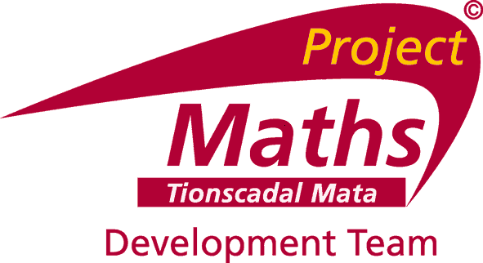

PART-TIME OPPORTUNITIES IN TEACHER CONTINUING PROFESSIONAL DEVELOPMENT SUPPORT SERVICES

Project Maths Development Team (PMDT) is a Department of Education and Skills teacher support service, hosted in Drumcondra Education Centre. Its aim is to support schools in their implementation of Project Maths through the provision of appropriate high quality continuing professional development for mathematics teachers, and the provision of effective teaching and learning resources.

PMDT currently has a number of part-time opportunities nationally for the position of Associate.

A panel may be formed from which future vacancies may be filled.

For further details on these positions, including a job description and application form, please go to http://www.projectmaths.ie or http://www.ecdrumcondra.ie.

Closing date: Friday 8th May 2015 at 5pm.

