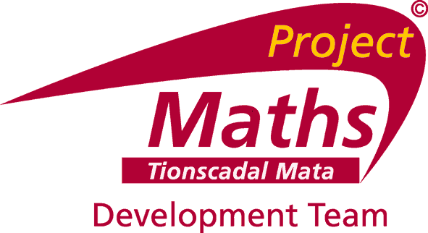

PROJECT MATHS DEVELOPMENT TEAM (PMDT)

REGIONAL DEVELOPMENT OFFICER (RDO)

The Project Maths Development Team was established by the Department of Education and Skills (DES) to support the phased implementation of syllabus change in post-primary mathematics, in all post-primary schools, from September 2010. A comprehensive programme of teacher professional development has been put in place and the PMDT has been delivering workshops and seminars nationwide since September 2009.

The Teacher Education Section of the DES proposes to recruit one RDO to join the PMDT from September 2015.

Applications are now invited from suitably qualified teachers of mathematics who are fully registered with the Teaching Council and who currently hold a recognised post in a recognised post-primary school or who are on secondment from such a position.

Ideally applicants should meet the following criteria:

- be committed to the development of the teaching and learning of mathematics and have at least five years' experience of teaching the subject at second-level, up to and including Leaving Certificate higher level
- have a thorough knowledge of Project Maths, the education system and of the curriculum at second level
- have had involvement in curricular innovation/development and/or experience in the design and delivery of teacher professional development courses
- have excellent interpersonal, communication, facilitation and presentation skills
- have excellent organisation, management and ICT skills

Secondment to the team will be effective from September 2015. Candidates must be eligible for full-time secondment as per circular 0107/2006. The person appointed will be seconded for an initial period of one school year, subject to satisfactory completion of a 3 month probationary period, with a possibility of further extensions available in line with DES regulations for secondments.

A panel may be formed from which future vacancies may be filled.

The Project Maths Development Team is administered by Drumcondra Education Centre.
Application forms and additional information are available by clicking on the links below or from:

Ms Grainne Haughney
The Project Maths Development Office
Drumcondra Education Centre
Drumcondra
Dublin 9
Tel: 01 8576422
E-mail: grainneh@ecdrumcondra.ie

Download: Job Description and Application Form on www.projectmaths.ie

The closing date for receipt of completed application forms is 5.00 pm, Friday 8 May 2015
All applications will be acknowledged. Applicants should note that short-listing may apply.

