Problem-Solving Questions (JC)

- True/False. In the diagram below the angles and are complementary. Justify your answer.

α

β

- One approach to solving problems is proof by superposition. This involves proving a special case, then using the special case to prove the general case.
Using proof by superposition show that the area of a triangle is
Questions you might consider:
- What special case should be chosen?
- How can such a case be generalised?

- A trapezoid is a four-sided object with two sides parallel to each other. An example of a trapezoid is shown below.
h
b₁
b₂

Show that the area of a trapezoid is given by the formula
(HL)

- True/False. A triangle can have two obtuse angles. Justify your answer.

- In the diagram below find the measure of the angle if AB = AC and AE = CE = BC
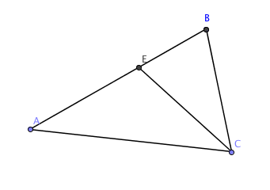

α

- If the length of a rectangle is halved and the width is tripled how is the area of the rectangle affected?

- A mathematics test has 25 questions. Four points are given for each correct answer1 point is deducted for each incorrect answer. If Brad answered all questions and scored 35. How many questions did he answer incorrectly?

- A playground has 3 entrances, each equally likely to be used. What is the probability that two children entering the playground will use the same entrance?

- The yearly change in the yield of milk on a dairy farm over four consecutive years was as follows: An increase of x% in each of the first two years, followed by a decrease of x% in each of the next two years. Assuming that at least some milk was produced during the period described what has happened to the yield of milk from the beginning of the four-year period to the end?

- Using GeoGebra, draw a circle of area If the radius of a circle is decreased 3 cm, by what percentage is (a) its circumference and (b) its area decreased. (Note for Teachers:- This provides a good opportunity to demonstrate the versatility of GeoGebra. A slider set from 0 – 5, with whole-number increments could be used to change the radius. The change in area and circumference could be recorded on a table on screen also.)

- A pile of gold dust is divided among three prospectors. Calamity Jane and Wild Bill get and of the dust respectively. Bobby "Nugget" Smith gets the remaining 14 grams. How many grams does Calamity and Wild Bill each get?

- Which of the following must be an even integer?
  - The average of two even integers
  - The average of two prime numbers
  - The average of two perfect squares
  - The average of two multiples of 4
  - The average of three consecutive integers
Explain your reasoning or show a counter example in each case

- Six identical rectangles with height h and width w are arranged as shown. The line segment PQ intersects the vertical side of one rectangle at X and the horizontal side of another rectangle at Z. If the right-angled triangle XYZ is such that Y Z = 2XY, find the value of .

- A gumball machine that randomly dispenses one gumball at a time contains 13 red, 5 blue, 1 white, and 9 green gumballs. What is the least number of gumballs that a customer must buy to guarantee that he/she receives 3 gumballs of the same colour?

- In the diagram, the two circles are centred at O. Point S is on the larger circle. Point Q is the point of intersection of OS and the smaller circle. Line segment PR is a chord of the larger circle and touches (that is, is tangent to) the smaller circle at Q. Note that OS is the perpendicular bisector of PR. If and QS = 4, find the length of the radius of the larger circle.

- A palindrome is a positive integer that is the same when read forwards or backwards. For example, 545 and 1331 are both palindromes. Find the difference between the smallest and largest three-digit palindromes.

- A 51 cm rod is built from 5 cm rods and 2 cm rods. All of the 5 cm rods must come first, and are followed by the 2 cm rods. For example, the rod could be made from seven 5 cm rods followed by eight 2 cm rods. How many ways are there to build the 51 cm rod?

- The sum of four numbers is x. Suppose that each of the four numbers is now increased by 1. These four new numbers are added together and then the sum is tripled. What is the value, in terms of x, of the number thus formed?

- In the figure below, ABCD is a rectangle. The points A, F, and E lie on a straight line. The segments DF, BE, and CA are each perpendicular to FE. Denote the length of DF by a and the length of BE by b. Find the length of FE in terms of a and b.

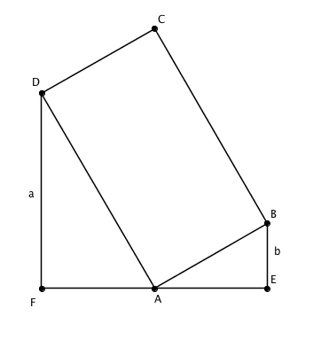

- The average age of a group of mathematicians and computer scientists is 40. If the mathematicians' average age is 35 and the computer scientists' average age is 50, what is the ratio of the number of mathematicians to the number of computer scientists?

- A rectangle with unequal sides is placed in a square so that each vertex lies on a side of the square and divides the side in the ratio 1:2. Find the fraction of the area of the square that is covered by the rectangle.
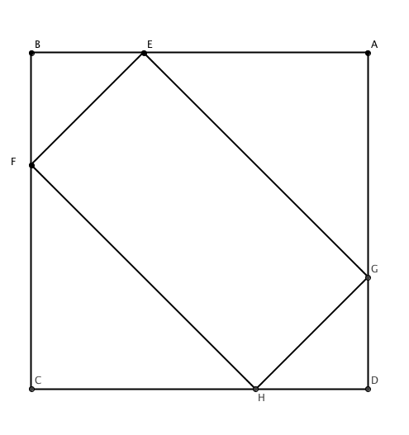
- (a) How many 10-digit positive integers use each and every one of the ten digits 0, 1, _ _ _ , 9 once and once only?
(b) How many 10-digit numbers are there?

- Richie's King Henry training shoes have 9 eyelets on each side, spaced 0.7 cm apart. Using the standard lacing shown below. Richie laces his right shoe so that there is 1.4 cm between the two parallel rows of eyelets. This leaves 15 cm of lace free on each side for tying. How long is the lace?

- What is the area of the shaded square shown if the larger square has sides of length 1 and E,F, G and H are respectively the mid points of each of the four sides?
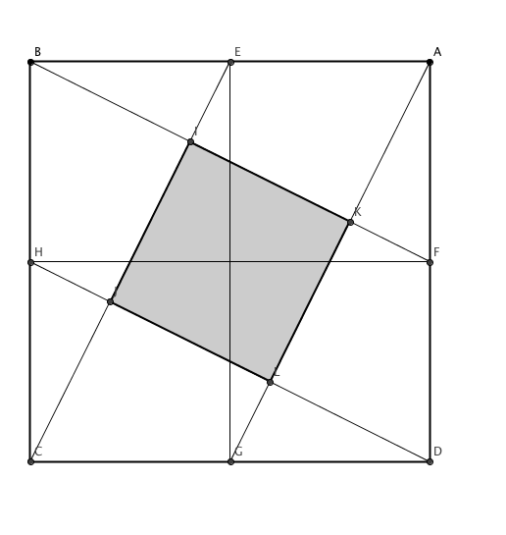
- Without using a calculator or a computer, determine which of the two numbers or is larger?

- A machine-shop cutting tool has the shape of a notched circle, as shown. The radius of the circle is 50 cm, the length of CD is 6 cm. The angle CBD is a right angle. Find the distance from D to the centre of the circle (A).
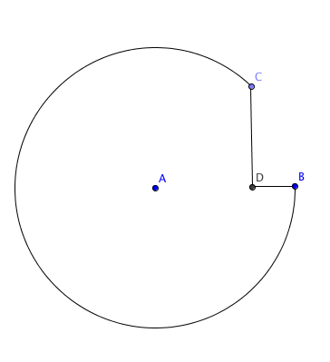
- The numbers 1447, 1005, and 1231 have something in common: each is a four-digit number beginning with 1 that has exactly two identical digits. How many such numbers are there?

- The diagram below shows the number of employees plotted against their length of service with a given company. The vertical axis indicates the number of employees but the scale was accidentally omitted from this graph. What percent of the company’s employees have worked there for 5 years or more?

- What do the numbers 2335, 1446, and 1321 have something in common? How many such numbers are there?

- Can you find a rule to describe numbers in the sequence; 101, 104, 109, 116, …

Find the next four terms in the sequence

- Mrs Gallagher bought a new plant for my garden and asked her children to guess the type and colour of the plant. Conor said it was a red rose, Sharon said it was a purple daisy, and Orla said it was a red dahlia. Each was correct in stating either the colour or the type of plant. Identify the plant bought by Mrs Gallagher? Explain your reasoning

- A pool has a volume of 2000 litres. Tommy starts filling the empty pool with water at a rate of 10 litres. The pool springs a leak after 10 minutes and water leaks out at 1 litre per minute from then on. Beginning from the time when Tommy starts filling the empty pool, how long does it take to completely fill the pool?
- What is the surface area of a cube of side 5 cm? Three such cubes are joined together side-by side as shown. What is the surface area of the resulting cuboid?
Diagram not to scale

- In the diagram, a garden is enclosed by six straight fences. If the area of the garden is , what is the length of the fence around the garden?

- The first four terms of a sequence are 1, 4, 2, and 3. Beginning with the fifth term
in the sequence, each term is the sum of the previous four terms. Therefore, the fifth term is 10. What is the eighth term?

- The set contains the first 50 positive integers. After the multiples of 2 and the multiples of 3 are removed, how many integers remain in the set S?

- On the number line, points P and Q divide the line segment ST into three equal parts. What is the value at P?

- Two circles are centred at the origin, as shown. The point is on the larger circle and the point is on the smaller circle. If , what is the value of s?
- In the diagram, there are 26 levels, labelled. There is one dot on level A. Each of levels contains twice as many dots as the level immediately above. Each of levels contains the same number of dots as the level immediately above. How many dots does level Z contain?

- In the figure below, B, C, D are points on the circle with centre O, and the lengths of the segments . If the , find in terms of α.
- A hybrid car can run on petrol or on ethanol. It can drive for 495 kilometers on 45 litres of petrol and it can drive 280 kilometers on litres of ethanol. If the price of petrol € 1.61 per litre, find the price per litre of ethanol which will give the same cost per kilometre as petrol?

- The lengths of the sides of a triangle 2 cm, 2 cm and cm respectively
Which of the following can be true?
(a) The triangle has an angle of 45 degrees
(b) The triangle is isosceles
(c) The area of the triangle is
(d) The perimeter of the triangle is 5
(e) No such triangle exists
Explain your reasoning

- Determine which of the following statements is true for any two integers p and q where 11 is a factor of
(a) 11 is a factor of
(b) 11 is a factor of
(c) 22 is a factor of
(d) 11 is not a factor of
(e) is a factor of 11.
Explain your reasoning

- The circles shown below are concentric and have radii of length 3 cm, 4cm, 5cm and 6 cm respectively. What is the probability that a random shot that hits the target will hit the bull’s eye (i.e. land in the innermost circle)?

- Let k be an integer. Which of the following is always greater than k?
(a)
(b)
(c)
(d)
Explain your reasoning

- Let k be a real number. Which of the following is always greater than k?
(a)
(b)
(c)
(d)
Explain your reasoning

- If the pattern below continues, what will be
      - The first number in the 5th row
      - The last number in the 6th row
      - The middle number in the 7th row
In which row will the number 289 appear?

