**The Purpose of this Document**

The purpose of the attached questions is to begin to shift the the emphasis from teaching problem solving to teaching *via* problems. The focus is on teaching mathematical topics through problem-solving contexts and enquiry-oriented environments which are characterised by the teacher 'helping students construct a deep understanding of mathematical ideas and processes by engaging them in doing mathematics: creating, conjecturing, exploring, testing, and verifying. Specific characteristics of a problem-solving approach include:

* Interactions between students/students and teacher/students (Van Zoest et al., 1994)
* Mathematical dialogue and consensus between students (Van Zoest et al., 1994)
* Teachers providing just enough information to establish background/intent of the problem, and students clarifying, interpreting, and attempting to construct one or more solution processes (Cobb et al., 1991)
* Teachers accepting right/wrong answers in a non-evaluative way (Cobb et al., 1991)
* Teachers guiding, coaching, asking insightful questions and sharing in the process of solving problems (Lester et al., 1994)
* Teachers knowing when it is appropriate to intervene, and when to step back and let the pupils make their own way (Lester et al., 1994)
* A further characteristic is that a problem-solving approach can be used to encourage students to make generalisations about rules and concepts, a process, which is central to mathematics (Evan and Lappin, 1994).[1]

Although mathematical problems have traditionally been a part of the mathematics curriculum, it has been only comparatively recently that problem solving has come to be regarded as an important medium for teaching and learning mathematics (Stanic and Kilpatrick, 1989). In the past problem solving had a place in the mathematics classroom, but it was usually used in a token way as a starting point to obtain a single correct answer, usually by following a single 'correct' procedure. More recently, however, professional organisations such as the National Council of Teachers of Mathematics (NCTM, 1980 and 1989) have recommended that the mathematics curriculum should be organized around problem solving, focusing on:

* Developing skills and the ability to apply these skills to unfamiliar situations
* Gathering, organising, interpreting and communicating information
* Formulating key questions, analyzing and conceptualizing problems, defining problems and goals, discovering patterns and similarities, seeking out appropriate data, experimenting, transferring skills and strategies to new situations.
* Developing curiosity, confidence and open-mindedness (NCTM, 1980, pp.2-3).

The questions attached to this document are intended to engage the students in problem solving where the focus is on the process rather than the answers they ultimately achieve. The problems are drawn from different syllabus strands and clearly can only be introduced once the students have mastered the appropriate content and while the problems are aimed at different levels, the more able students should be exposed to the simpler problems before advancing to the more complex ones.

The following checklist may prove useful in engaging the students in the problem-solving process.

**Understanding**

Does the student understated the problem?

Make sure that the students read and re-read the question and that they identify all the clues, what they are being asked to find and any conditions attaching to the problem.

**Planning**

Once the students understand the problem encourage them to plan a solution and to identify appropriate strategies and tools, referencing any similar problem they may have previously encountered. Can the students explain their reasoning?

**Experimentation**

Check to see if the agreed strategies work. Decide if each step in the solution is correct. How do the students know that the steps are correct? Can the students explain and/or defend their reasoning?

**Reflection**

Is the students’ solution valid?

Can the students show that the result is correct?

Can they suggest alternative methods of solving the problem?

**Note:** There are no solutions provided, however if assistance is required feel free to contact seamus_knox@education.gov.ie.

1. A person wishes to move from a point A to a point E via a point C on a line segment [BD]. The segments [AB] and [ED] are perpendicular to [BD]. If , and, find if the total distance travelled is to be a minimum.



***Note for Teachers:*** It is not necessary to use calculus here, indeed a much neater solution is found if geometry is used (the triangle inequality and similar triangles). Get the students to draw a diagram and discuss the possibilities in order to see how to proceed

***Hint:*** Map E through [BD] and find the straight-line distance through C to [ED’]

Answer: 

1. 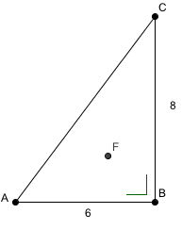Three roads, as shown, join three villages A, B and C.

The road lengths in two of the cases are shown and two of the roads meet at right angles at B. A mobile phone mast is to be erected in the area between the villages as shown. It was suggested that it would be fair to erect it at a point equidistant from the three villages. Why was it not possible to do so? It was then decided to erect the mast at F, which is equidistant from the three roads.

* 1. How far is F from each road?
  2. Which village is now nearest the mast?

***Note for Teachers***: Get the students to:

1. Arrive at the names of the points, which are (i) equidistant from the three points and (ii) from the three roads.
2. Discuss the properties of these points and to draw good diagrams.
3. Recognise that as the triangle is right-angled this has consequences for the location of the circumcentre and that the radius of the incentre is the altitude of triangles containing F and the vertices of the triangle

***Hint***: Find the area of the triangle and of the three triangles containing F and the vertices of the triangle.

**Answers** (i) Radius of Incentre is 2 and B is closest to the mast

1. The diagram shows part of the specification diagram for a metal washer. The line segment DC is 36 mm long. Find the area of the annulus (shaded region).

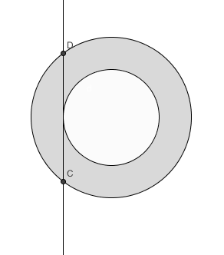

If the washer is 0.1 mm thick find the volume of metal in the washer.

If of the metal has mass 5*g*, find the mass of the washer.

If the material from which the washer is to be manufactured costs €250.00 per tonne, find the cost of manufacturing 120,000 washers

***Note for Teachers***: Get the students to:

1. Research the relevant circle theorems.
2. Find a general equation for the area of any annulus.
3. Construct a radius (R) for the outer circle to D and for the inner circle to the point of tangency (call this r).

Repeat the question above where the sides of the equilateral triangle, shown, are of length 6 cm

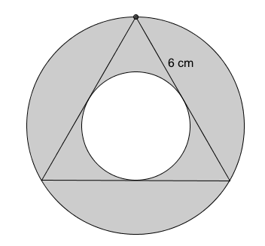

1. At a certain latitude the number (*d*) of hours of daylight in each day is given by , where *A* and *B* are positive constants and *t* is the time in days after the spring equinox.

Assuming the number of hours of daylight follows an annual cycle of 365 days; find the value of k correct to three decimal places.

* 1. If the shortest and longest days have 6 and 18 hours of daylight respectively state the values of *A* and *B*.
  2. Find in hours and minutes the amount of daylight on New Year’s day which is 80 days before the spring equinox.
  3. A town at this latitude holds a fair twice a year on days that have exactly 10 hours of daylight. Find, in relation to the spring equinox, which two days these are.

1. If the depth of water in a canal varies between a minimum 2 m below a specified buoy mark and a maximum of 2 m above this mark over a 24-hour period. Construct a formula involving a trigonometric function to describe this situation.

The road to an island close to the shore is sometimes covered with water. When the water rises to the level of the road, the road is closed. ***On a particular day, the water at high tide is 5 m above the mean sea level***. Show that the height of the tide is modelled by the equation where t is the time in hours from high tide and h is the height of the tide in metres. If high tide occurs every 12 hours find:

1. The value of *k*. (Ans. 30)
2. The height of the road above sea level if the road is closed for 3 hours on the day in question. (Ans 3.52 metres )

If the road were raised so that it is impassable for only 2 hours 20 minutes, by how much was it raised?

***Note for Teachers***: The motion of the water is essentially simple and harmonic and obeys and can be modelled by either the sin or cosine functions

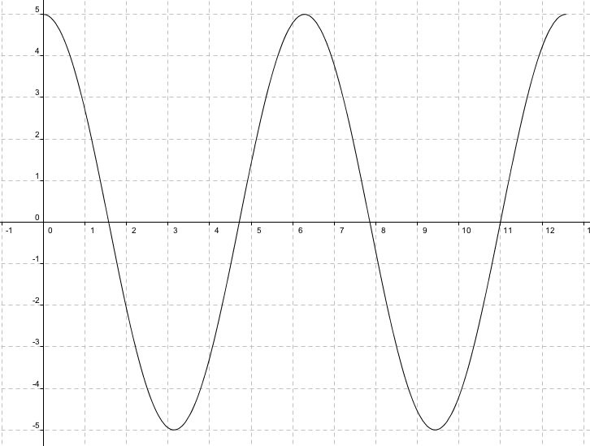

*Diagram showing* 

1. Ask the students to establish the period of the cycle and relate this to.
2. Ask them to find the range of the function and relate this to the height of the high tide.
3. Get them to construct a radius (R) for the outer circle to D and for the inner circle to the point of tangency (call this r).

**Example**

By completing the square, solve the equation  and find the coordinates of its turning point



Since , the minimum value of is -2 as the minimum value of which occurs when . The turning point is .

1. The Point O is the intersection of two roads that cross at right angles as shown. One car travels towards O from the north at  while the second travels due east towards O also at .



1. Show that after *t* seconds their distance apart, d, is given by



1. Show that this simplifies to



1. Show, without using calculus, that the minimum distance between the two cars is .
2. A line has equation . Show that the distance from to any point on the line is given by: , and show that
   1. 
   2. 
   3. By completing the square show that the minimum value for *d* is 
3. The diagram below shows a velocity/time graph for a car moving along a flat road. The total journey time is 5 minutes.



Find:

* 1. The acceleration for the three different phases of the journey.
  2. The total distance travelled.
  3. Find the average velocity for the journey

1. The graph below shows the velocity/time graph for a body rising vertically against gravity.

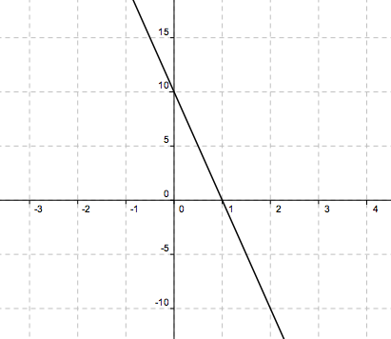

Velocity (ms-1)

Time (s)

If the body was thrown from an initial height of 8 m above the ground, draw a graph of the height of the body against time and find:

* 1. The velocity with which the body was initially thrown
  2. The greatest height reached
  3. The time taken for the body to strike the ground.

1. A sprinter in a 100-metre race reaches a top speed of 15ms-1 after running 60 m. Find the sprinter’s average speed for this portion of the race. If he maintains this top speed for the remainder of the race, find the time taken to complete the race.

Draw separate sketches, in each case to show how (a) the distance travelled by the sprinter and (b) the sprinter’s velocity varied with time

1. The rate at which a radioactive sample decays is given by the equation



where  is the decay constant and N is the number of nuclei in the sample.

The minus sign indicates that the number of nuclei decreases with the passage of time.

Write down similar equations to represent the following statements:

1. The rate of growth of bacteria is proportional to the number of bacteria present
2. The rate at which a body cools in a freezer is proportional to its temperature
3. The rate at which a body cools in an ambient room is proportional to the difference between its temperature and that of the room.
4. The cost encountered by a firm which makes dresses are of two types:

Fixed costs of €2000.00 per week and production costs of € 20 for each dress made.

Market research indicates that if they price the dresses at €30.00 each they will sell 500 per week and if they set the price at €55.00 they will sell none. Between these two extreme values, the graph of sales against price is a straight line.

If the company prices the dresses at € *x* a pair where , find expressions for

1. The weekly sales
2. The weekly receipts
3. The weekly costs

Hence show that the profit € P is given by and find the price at which each dress should be sold to maximise the profit.

1. The diagram below shows a portion of the graph of the function  and a chord of the function passing through the points A (0,-2) and B(2,2) respectively.

Find:

* 1. The value of *a*, *b* and *c.*
  2. The average rate of change from A to B
  3. The point on the curve where the instantaneous rate is equal to the rate in (b), above.

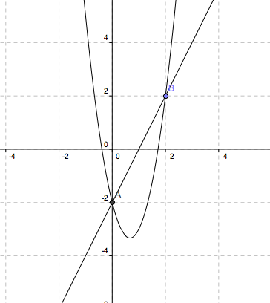

1. The diagram shows a sketch of the graph of  together with the tangent to the curve at the point A (1,0).

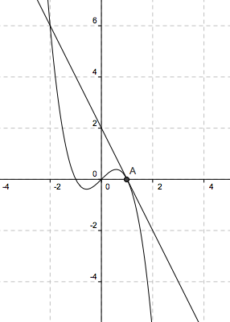

Find the equation of the tangent at A and verify that the point where the tangent again meets the curve has coordinates (-2,6).

Use integration to find the area of the region bounded by the curve and the tangent, giving your answer as a fraction in its lowest terms.

1. The diagram below shows part of the curve of 

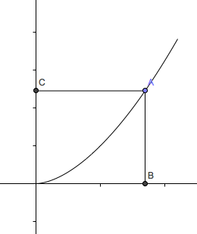

O

Show that the curve divides the area of the rectangle OAPB into two regions whose areas are in the ratio .

1. 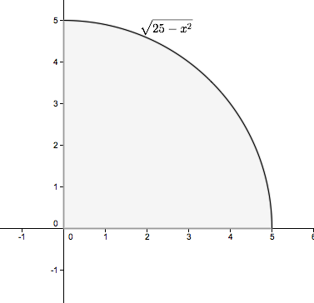The diagram shows part of a circle having centre at (0,0) and radius of length 5.
   1. Use the trapezoidal rule with 10 intervals to find an approximation to the area of the shaded region.
   2. Does the trapezoidal rule overestimate or underestimate the true area
   3. Find the exact area of the shaded region
   4. Use the answers from (b) and (c) to estimate a value for p.
2. The diagram below shows part of a security barrier placed above a gate at St. John’s College, Johannesburg, South Africa. The barrier is in the shape of a semicircle with a number of evenly- spaced vertical bars running through it. The semicircle is then decorated with smaller circles as shown

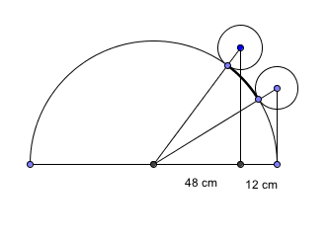

A

B

The vertical bars in the semi-circle are evenly spaced with a gap of 12 cm between successive bars. The exterior diameter of circles A and B is also 12cm. The centre of circle A is vertically above the first vertical bar inside the inner semi-circle. The centre of circle B is vertically above the right edge of the inner semicircle. How far apart on the semi-circle are the points of tangency of circles A and B to the semi-circle? The situation is illustrated in the diagram below. (Source: Alabama Journal of Mathematics).

1. Bailenahare and Cathairtortoise are 160 km apart. A hare travels at 12 km per hour from Bailenahare to Cathairtortoise, while a tortoise travels at 4 km per hour from Cathairtortoise to Bailenahare. If both set out at the same time, how many kilometres will the hare have to travel before meeting the tortoise en route?

1. The distance between Athlone Station and Heuston Station is 120 km. A train starts from Athlone towards Heuston Station. A bird starts at the same time from Heuston Station straight towards the moving train. On reaching the train, it instantaneously turns back and returns to Heuston Station. The bird makes these journeys from Heuston Station to the train and back to Heuston Station continuously till the train reaches Heuston Station. Calculate the total distance in km the bird travels in the following two cases:   
   Case 1: The bird flies at 80 km per hour and the speed of the train is 60 km per hour.   
   **Case 2:** The bird flies at 60 km per hour and the speed of the train is 80 km per hour.   
   **Extension**   
   How many journeys back and forth does the bird make in Case 1?   
   Would the distances in these back and forth journeys form an infinite series with a finite sum?
2. There is a pole in a lake. One-half of the pole is in the ground, another one-third of it is covered by water, and 9 m is out of the water. What is the total length of the pole in m?
3. In the following two groups of shapes, which does not belong to the group?

Explain your answer in each case.

Set **1.**   
 http://www.syvum.com/iosundry/iq/oddo1a.gif http://www.syvum.com/iosundry/iq/oddo1c.gif http://www.syvum.com/iosundry/iq/oddo1b.gif http://www.syvum.com/iosundry/iq/oddo1d.gif

**Set 2.**

http://www.syvum.com/iosundry/iq/oddo7a.gifhttp://www.syvum.com/iosundry/iq/oddo7c.gifhttp://www.syvum.com/iosundry/iq/oddo7b.gifhttp://www.syvum.com/iosundry/iq/oddo7d.gifhttp://www.syvum.com/iosundry/iq/oddo7b.gif

1. In the following sequence of numbers, give the next two numbers in the sequence.

Explain your answer in each case.

* 1. 1, 3, 6, 10, 15, 21, 28, _______
  2. 0, 1, 1, 2, 3, 5, 8, 13, 21, 34, _______
  3. 2, 6, 12, 20, 30, 42, 56, _______
  4. 1, 2, 6, 24, 120, _______
  5. 1/4, 0, 1, -3, 13, -51, 205, _______
  6. 1, 2, 10, 37, 101, _______
  7. 7, 26, 63, 124, 216_______
  8. 2, 5, 17, 65, 256_______
  9. 361, 289, 225, 169, 121 _______
  10. 96, 88, 80, 72, 64, ______

1. I have 15 cards numbered 1 to 15. I put down seven of them on the table in a row.  
   The numbers on the first two cards add to 15.The numbers on the second and third cards add to 20.The numbers on the third and fourth cards add to 23.The numbers on the fourth and fifth cards add to 16. The numbers on the fifth and sixth cards add to 18. The numbers on the sixth and seventh cards add to 21.  
   What are my cards?  
   Can you find any other solutions?

How do you know you've found all the different solutions?

B

C

A

D

F

E

1. In the diagram above, the triangle ABC is right-angled at A. BD is perpendicular to BC and is equal in length to BC. E is the foot of the perpendicular from D to AC and F is the foot of the perpendicular from B to DE. Prove that
2. 
3. |BF| = |BA|
4. |DE| = |BA| + |AC|.
5. In the diagram below, ABEF and ACGH are squares. BH and CF meet at P.  
   Prove that the triangles ABH and AFC are congruent.

B

C

A

H

F

E

G

P

1. O is a point inside an acute-angled triangle ABC. The feet of the perpendiculars from O to BC, CA and AB respectively are P, Q and R. Prove that



B

A

C

O

Q

P

R

1. A cone and a cylinder made from lead each have a radius *r* cm and height of 2*r* cm. A sphere is also made from the same material and has also a radius of *r* cm. Find
2. The ratio of the volumes of these lead shapes.
3. The ratio of the curved surface areas of these lead shapes.
4. 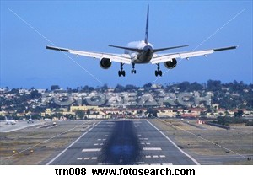C:\Users\Sheelagh\AppData\Local\Microsoft\Windows\Temporary Internet Files\Content.IE5\7UWVH7D3\MCj04242060000[1].wmfCommercial aircraft fly at altitudes of between 29,000 and 36,000 feet (between 9 and 11 kilometres). An aircraft begins its gradual descent a long distance away from its destination airport. We will assume that the path of descent is a straight line.
5. An aircraft is flying at an altitude of 10 km and the angle of descent is 2 degrees. At

what distance from the destination runway should the descent begin?

1. An aircraft is flying at an altitude of 9.3 km. A passenger becomes ill and the pilot

needs to land at the nearest airport which is 200 km away. What will the angle of descent be?

1. 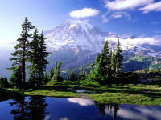Standing in the foreground of this picture on the shore of the lake, a forester wishes to calculate the height of one of the trees across the lake. He marks a line [AB] along the shore and measures it using a 100m tape measure. He takes the base of the tree to be located at a point C. Using a theodolite (surveying instrument used for measuring angles) he measures |<ABC| and |<BAC|. From A, he measures the angle of elevation θ of the top of the tree. Sketch the situation.

[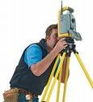](http://images.google.ie/imgres?imgurl=http://www.letsblogconstruction.com/photos/uncategorized/2008/08/26/s6_surveyor.jpg&imgrefurl=http://www.letsblogconstruction.com/letsblogconstruction/2008/08/the-difference.html&usg=__98yCIHmiam-M9UyXi9DK2REUkE8=&h=431&w=394&sz=21&hl=en&start=5&itbs=1&tbnid=mp0Fft3203GQZM:&tbnh=126&tbnw=115&prev=/images?q=a+theodolite&gbv=2&hl=en)

How will he use the measurements taken to calculate the height of the tree? The forester is 185 cm tall.

Use a set of possible measurements to calculate the height of the tree. (Do you think your answer is realistic?)

1. A developer asks a surveyor to calculate the area of the following site which can be approximated to a pentagon as shown below. The surveyor uses a theodolite to measure all the given angles.

The surveyor does not need to use the theodolite to measure the 5th angle in the diagram.

What is the measure of the missing angle?

Find the area of the site.

A hectare is 10000 m2. What fraction of a hectare is this site?

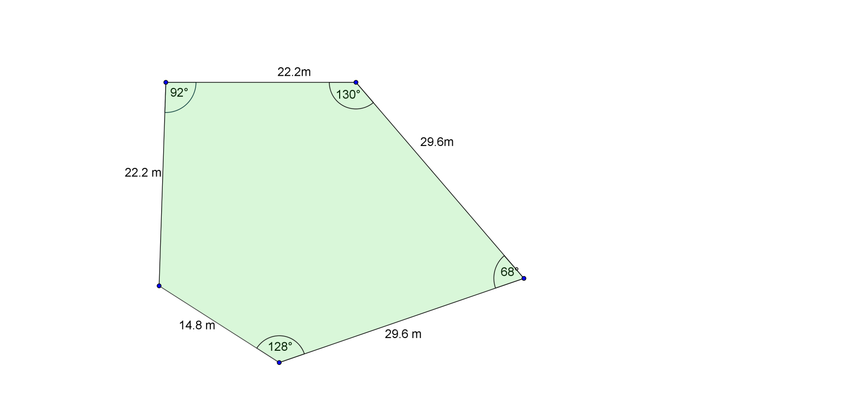

1. The width of a quarry between two points A and B has to be measured. The quarry is flooded after heavy rain and is inaccessible.

***Y***

***P***

***A***

***B***

***X***

It is decided to find the distance from a point P to each side of the quarry as shown below using a trundle wheel.

The midpoint of [AP] and [BP] are then found and marked as X and Y. The distance |XY| is measured and multiplied by 2 to give the width of the quarry. Two theorems are being applied here? Can you state them?

In the question above, if the ground between AB and P was inaccessible due to being waterlogged the surveyors would need to come up with a different technique.

***A***

***B***

***R***

***S***

X

A suggestion was made that a base line RS would be marked out where the ground was drier and then its length accurately measured. Then points A and B would be sighted from points R and S and <ARB, <BRS, <ASR, and <BSA measured. How can this information be used to measure the distance AB? Possible values can be used for |RS| and the angles listed in order to test the methodology.

1. The mast of a crane (AC) is 33 m in height.

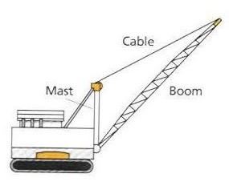By adjusting the length of the cable, (from A to B) the operator of the crane can raise and lower the boom.

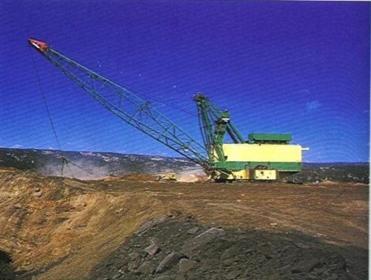

B

A

C

(a) What is the minimum distance possible from A to B?

(b) When the boom of the crane, (CB), is fully lowered point B is on the horizontal ground. At this stage the size of the angle ACB is 120°.  
What is the length of the cable now between A and B, to the nearest metre?  
(c) If point C is 1.3 m above the ground when, how far is the point B from the base of the crane (line AC) when the boom is fully lowered to the ground(to nearest metre)?

1. A car jack as in the picture above consists of a pair of triangles with one common side, which is variable in length.

[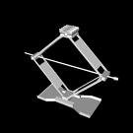](http://images.google.ie/imgres?imgurl=http://www-roc.inria.fr/gamma/OBJECTS/SCHNAUZER/MECHANICAL/31-car-jack.jpeg&imgrefurl=http://www-roc.inria.fr/gamma/download/affichage.php?dir=MECHANICAL&name=31-car-jack&last_page=35&usg=__aOYJlNouoIJLb7a93VBJRDsfAfs)

Y

X

Threaded Rod

A

B

The side AX, AY, XB and BY are all the 18 cm long.

Points X and Y are connected by a threaded rod.

The rod can be rotated in either direction thus increasing or decreasing |XY| depending on the direction in which it is rotated.

1. What is the mimimum value of |XY| needed so that when the jack is stored in the boot of the car the points A and B are as close as possible.
2. As |XY| decreases how do the angles in triangle AXY change?
3. How does the height of the jack depend on the height of triangle AXB drawn from point A to base XY?
4. When the |XY| = 20cm, find |AB|?
5. If |XY| = *w* and |AB| = *h*, write h in terms of *w*.

1. [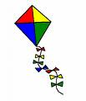](http://images.google.ie/imgres?imgurl=http://members.cox.net/kiter/hkf/kite_lbl_02.jpg&imgrefurl=http://members.cox.net/kiter/hkf/hamm.html&usg=__6ivDFxLNJcm9YLzYgjDoh0Gmvb0=&h=350&w=300&sz=27&hl=en&start=1&itbs=1&tbnid=VoWvt2CUc7DrFM:&tbnh=120&tbnw=103&prev=/images?q=kite&hl=en&sa=G&gbv=2&tbs=isch:1)A kite is a quadrilateral, which has two pairs of adjacent sides, which are equal in length.
   1. Plot the following coordinates. A(6,3), B(8,-1), C(6,-5), D(-8,-1). Do the coordinates when joined appear to form a kite? From the information given verify whether or not they form a kite.
   2. The lines joining opposite vertices of the kite are called cross braces. Find the midpoint of each crossbrace ([AC] and [BD].
   3. Verify that the midpoint of [AC] lies on [BD]
2. A recent advertisement for a particular model of car gave the fuel consumption figures shown in the table below.

|  |  |  |
| --- | --- | --- |
| **Category of travel** | **Miles per gallon** | **Litres per 100 km** |
| Urban | 28.5 – 32.8 | 9.9 – 8.6 |
| Non-urban | 51.4 – 53.3 | 5.5 – 5.3 |
| Combined | 39.8 – 43.5 | 7.1 – 6.5 |

Based on this table, and assuming that this model of car is used, find each of the following correct to one decimal place. Explain your reasoning.

* 1. The most miles of urban travel that can be expected on a full tank (13.2 gallons) of fuel
  2. The maximum distance (in kilometres) for combined travel that can be expected on a full tank (60 litres) of fuel.
  3. The minimum number of additional litres of fuel that are needed to complete a non-urban journey of 1500 km, assuming there is a full tank (60 litres) of fuel at the start.
  4. The minimum number of litres of fuel that should be in the tank at the start in order to be certain of completing the journey described at (iii) above, if only one re-fuelling stop is permitted during the journey.

1. A patient is prescribed daily medication that must contain at least 5 units of vitamin A and at least 9 units of vitamin B. These vitamins are available in both tablet and capsule form. Each tablet contains 2 units of vitamin A and 1 unit of vitamin E. Each capsule contains 1 unit of vitamin A and 3 units of vitamin E.
2. If *x* and *y* are the daily doses of tablets and capsules respectively, write down two inequalities in x and y.
3. If the combined number of tablets/capsules the patient takes in a day must not exceed 6, list the combinations of tablets and capsules that satisfy the patient’s medication prescription.
4. If each tablet costs 20 cent and each capsule costs 50 cent, what is the minimum and what is the maximum daily cost of the medication?
   1. Two functions are defined as follows:

*f*(*x*) = (3 + *x*)(2 – *x*) and *g*(*x*) = (3 – *x*)(2 + *x*).

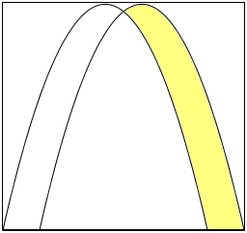

1. Show that the graphs of these two functions have a common point on the *y*-axis.
2. A company wants to use the logo shown above and decides to base it on these two functions. The shaded region is that part of the positive quadrant which is bounded by the two functions and the section of the *x*-axis from (2, 0) to (3, 0). Calculate this shaded area.
3. On a building site, sand is stored in a container which is 4 metres above ground. The sand is released through an opening in the floor of the container and forms a conical mound in which the height is equal to the diameter of its base.
4. If the sand is released at the rate of 500π cm3 per second, show that it will take less than 3 hours for the top of the mound of sand to reach the container.
5. Find the rate at which its height is increasing when the top of the mound reaches the container.
6. The diagram shows the graph of Sin *x* from *x* = 0 to *x* = π/2.

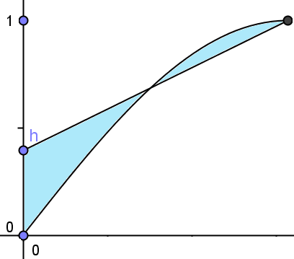

A line is drawn from a point *h* on the y-axis to the local maximum point on the Sin x graph as shown. Find the value of 0 < *h* < 1 which will make the two shaded areas equal.

1. A mains water supply runs along the straight boundary of a plot of land (see the Fig 1),which measures 1200 metres from **A** to **B**. The landowner wants to pump water from the mains to two sprinklers located at **C** and **D**, which are respectively 500 metres and 300 metres from the boundary, as shown. He has just one pump and wants to put it where he can use the shortest overall length of connecting water pipe. The diagram shows two of the many possible positions for the pump (labelled **P**1 and **P**2). The overall length of water pipe for location **P**1 is therefore |**CP**1| + |**P**1**D**|.

**Fig. 1**

**C**

**D**

500 m

300 m

**B**

**A**

mains pipe

P1

P2

1200 m

1. Calculate, to the nearest metre, the total length of connecting pipe needed if the pump is located at position
   1. **A** (ii) **B**
2. Using 1 cm to represent 100 m, draw a scaled diagram to represent this situation, showing positions **A**, **B**, **C,** **D** and **P**1 and show the scaled distances involved.
3. (i) Complete the table below, calculating the scaled lengths required in cm. correct to one decimal place.

|  |  |  |  |  |  |
| --- | --- | --- | --- | --- | --- |
| **Length |AP1| in cm** | **2** | **4** | **6** | **8** | **10** |
| **Length |CP1| in cm** | **5.4** |  |  | **9.4** | **11.2** |
| **Length |P1B| in cm** | **10** | **8** | **6** | **4** | **2** |
| **Length |P1D| in cm** | **10.4** |  |  | **5** | **3.6** |
| **Length |CP1| + |P1D| in cm** | **15.8** |  |  | **14.4** | **14.8** |

(ii) Estimate the shortest length of connecting pipe needed, to the nearest metre.

1. A water engineer represents the situation by a different diagram (see Fig. 2) and says that the minimum length of connecting pipe required is the length |**CE**|, where **E** is the image of **D** by axial symmetry in the line **AB**.
2. Show, by calculation or otherwise, that the engineer is correct.
3. If the pump is located at **P,** the point where [**AB**] and [**CE**]intersect, find the distance of the pump from **A**.
4. Hence, or otherwise, calculate the length of connecting pipe used in this arrangement, correct to the nearest metre.

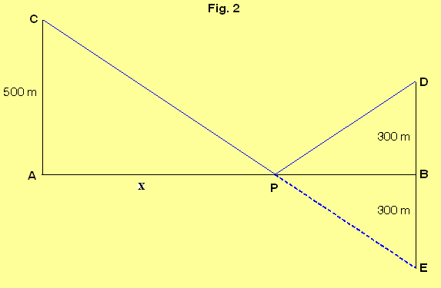

1. (HL Version) A mains water supply runs along the straight boundary of a plot of land (see Fig. 1 below) which measures 1200 metres from **A** to **B**. The landowner wants to pump water from the mains to two sprinklers located at **C** and **D**, which are respectively 500 metres and 300 metres from the boundary, as shown. He has just one pump and wants to put it where he can use the shortest overall length of connecting water pipe. The diagram shows two of the many possible positions for the pump (labelled **P**1 and **P**2). The overall length of water pipe for location **P**1 is therefore |**CP**1| + |**P**1**D**|.

**Fig. 1**

**C**

**D**

500 m

300 m

**B**

**A**

mains pipe

P1

P2

1200 m

1. Calculate, to the nearest metre, the total length of connecting pipe needed if the pump is located at position
   1. **A** (ii) **B** (iii) midway between **A** and **B**
2. (i) In Fig. 2, *x* represents the scaled distance from **A** to the pump location at **P**,  
    where 1 cm represents 100 metres. Express in terms of *x* the total scaled length  
    *t*of connecting pipe required.

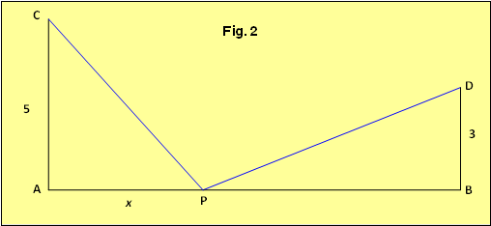  
(ii) Find the actual distance of the pump from **A** when the length of connecting pipe is a minimum and calculate this minimum length, giving your answers correct to the nearest metre.

1. Find the weight of the smallest column of air that will completely enclose the Eiffel tower. Take the density of air to be 1.22521 kg/m3.
2. How long it would take to return all of the gifts mentioned in the song ‘*The Twelve Days of Christmas’*, if they are returned one day at a time?
3. Show that every perfect square takes the form or , where k is an integer. Hence show that no number in the following sequence can be a perfect square.

1. Adapted from *What is a Problem Solving Approach?*