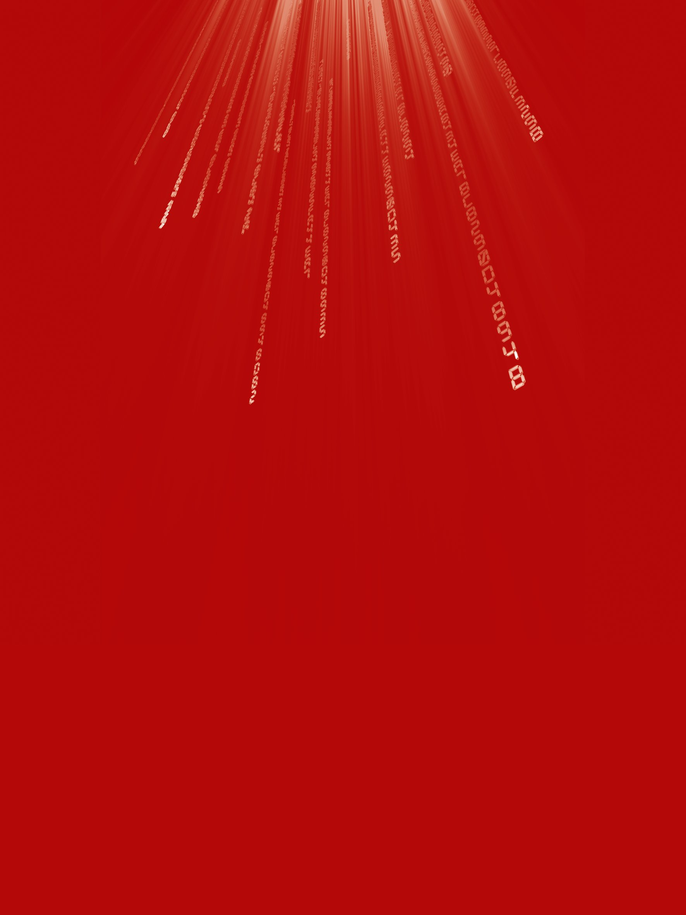
Teaching & Learning Plans
Decimals and Place Value
Junior Certificate Syllabus
Leaving Certificate Syllabus
Created by Teachers

The Teaching & Learning Plans are structured as follows:

Aims outline what the lesson, or series of lessons, hopes to achieve.
Prior Knowledge points to relevant knowledge students may already have and also
to knowledge which may be necessary in order to support them in accessing this new
topic.
Learning Outcomes outline what a student will be able to do, know and understand
having completed the topic.
Relationship to Syllabus refers to the relevant section of either the Junior and/or
Leaving Certificate Syllabus.
Resources Required lists the resources which will be needed in the teaching and
learning of a particular topic.
Introducing the topic (in some plans only) outlines an approach to introducing the
topic.
Lesson Interaction is set out under four sub-headings:
i. Student Learning Tasks – Teacher Input: This section focuses on teacher input
and gives details of the key student tasks and teacher questions which move the
lesson forward.
ii. Student Activities – Possible and Expected Responses: Gives details of
possible student reactions and responses and possible misconceptions students
may have.
iii. Teacher’s Support and Actions: Gives details of teacher actions designed to
support and scaffold student learning.
iv. Checking Understanding: Suggests questions a teacher might ask to evaluate
whether the goals/learning outcomes are being/have been achieved. This
evaluation will inform and direct the teaching and learning activities of the next
class(es).
Student Activities linked to the lesson(s) are provided at the end of each plan.

Teaching & Learning Plan:
Decimals and Place Value
Aims
- To consolidate students understanding of a place value number system
- To consolidate students’ understanding of the decimal system
- To consolidate students’ understanding of decimal operations
Prior Knowledge
Students understand integers and operations on integers, fraction concepts and operations on fractions and in whole number place value, the 10 to 1 relationship between any two adjacent values.
Learning Outcomes
As a result of studying this topic, students will be able to
- understand what a decimal is i.e. a fraction whose denominator is a power of 10 (used to be called decimal fractions)
- understand that the base 10 place value system extends infinitely in two directions, to large values(>1) and very small values(<1)
- understand that the decimal point is simply a convention to indicate where the unit’s position is - the position to the left of the decimal point being the unit position
- understand that while the symbols 3.75 and appear quite different both systems represent the same concepts
- think in terms of tenths, hundredths and other base 10 fractions and be able to read and write base ten fractions in different ways
- add and subtract decimals by adding numbers in like position value
- relate this to addition of fractions where we add fractions with common denominators - add tenths to tenths etc
- multiply and divide two decimal numbers and see that we get the same digits irrespective of where the decimal point is
- place the decimal point first by estimation when adding and subtracting two decimal numbers and then come up with a rule for this by seeing a pattern
- appreciate the use of the decimal system in our money system and our metric system

© Project Maths Development Team 2009 www.projectmaths.ie

Teaching & Learning Plan: Decimals and place value

Relationship to Junior Certificate Syllabus
Topic: Strand 3 Number | Description of topic  Students learn about | Learning outcomes  Students should be able to
3.1 Number Systems | Problems set in context, using diagrams to solve the problems so they can appreciate how the mathematical concepts are related to real life.  Algorithms used to solve problems involving fractional amounts. | use the equivalence of fractions, decimals and percentages to compare proportions
Relationship to Leaving Certificate Syllabus
Students learn about | Students working at FL should be able to | In addition students working at OL should be able to | In addition students working at HL should be able to
3.1 Number systems | Develop decimals as special equivalent fractions strengthening the connection between these numbers and fraction and place value understanding.
Resources Required
10 x 10 grids – large one for the class and templates for students, clear plastic sheets to enable grids to be reused, base 10 model (optional), wall poster on place value, hundredths discs and discs divided into different fractional parts, metre sticks

© Project Maths Development Team 2009 www.projectmaths.ie

Teaching & Learning Plan: Decimals and place value
Introducing the Topic
The Babylonians and the first place value number system.
The Babylonians (who lived in Mesopotamia in what is now Southern Iraq – between the Tigris and the Euphrates) had a base 60 number system which is credited as being the first place value number system. It appeared first around 3100 BC. They had no fractions as we have with numerators and denominators. What we call fractions they would have expressed as what we call decimals except using base 60 instead of base 10. They never used non terminating or repeating decimals but then they would have less repeating decimals in base 60 as 60 has prime factors 2,3, and 5 whereas 10 only has prime factors 2 and 5. The base 60 system was still in use in Europe in the 1500’s but the advantages of the base 10 system were becoming apparent.
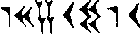
This numeral has been found on an old Babylonian tablet. It is an approximation for the square root of two. The symbols represent 1, 24, 51 and 10 i.e 1 x60⁰+24 x 60⁻¹+51 x 60⁻²+10 x 60⁻³ or approximately 1.414212.
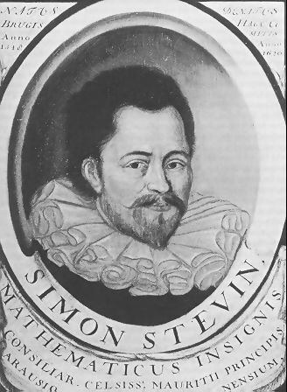Decimal systems were being used in ancient China, medieval Arabia and in Renaissance Europe. We cannot pinpoint any one person who invented decimals as such as many people worked with decimal systems throughout the ages. Decimal notation has however changed over the years. The Flemish mathematician Simon Stevin born in Bruges, Flanders (now Belgium) in 1548 was one of the first people to teach decimals in a very understandable way, but his notation differed from what we use today. He published a booklet called De Thiende (the tenth), first published in Dutch in 1585. Its sub title was: teaching how all computations that are made in business may be performed by integers without the aid of fractions.
Real Life Context
The following examples could be used to explore real life contexts.
- Money

- Metric system

© Project Maths Development Team 2009 www.projectmaths.ie

Lesson Interaction
Student Learning Tasks:  Teacher Input | Student Activities: Possible and Expected Responses | Teacher’s Support and Actions | Checking Understanding
Place value with whole numbers
- What does each of the fives in the number 5555∙0 mean? | - The 5 on the left of the decimal point is 5 units  - Next 5 is 50 = 5 x10  - Next 5 is 500 =  5 x100 = 5 x 10 x 10  - Next 5 is 5000  = 5 x 1000 = 5x 10 x10 | » Write the number on the board and ask students about each 5 in turn. | - Are students able to explain the place value of each number in a multi digit whole number?
» What happens to the value of each 5 as you move to the left of the unit place? | - It increases 10 times. |  | - Do students realise that moving one place to the left increases the place value by 10?
Introducing decimal fractions and ordering them
» Order these fractions from smallest to largest  » Explain your reasoning  » You may want to draw a number line to show approximately where each number is. | - Using equivalent fractions  or  •  and | » Write the fractions on the board. Wait a few minutes for students to work in their copies and then ask various students for their ordered lists.  If they are not all correct ask for explanations. Discuss different approaches. | - Can students use their ordering strategies from their prior knowledge of fractions?

KEY: » next step • student answer/response 4
Student Learning Tasks:  Teacher Input | Student Activities: Possible and Expected Responses | Teacher’s Support and Actions | Checking Understanding
- What do you notice about all of the above fractions? | - They are all proper fractions, <1  - Their denominators are all powers of 10. |  | - Do students notice that all the fractions we are dealing with here have denominators which are powers of 10?
- Because their denominators are all powers of 10, we can call these “decimal fractions” or base 10 fractions or just decimals. |  | - Review this quickly as students should know it from primary school but ensure that all the class are aware of it.
Writing tenths as decimals
- Instead of writing the fractionshow can we write these numbers in the decimal system?  - Describe how you went from representing these numbers as fractions to their decimal representation? | - 0.3, 0.5, 0.7  - You leave out the denominator, when it is a base 10 fraction, put in 0 if the fraction is <1(no units), a decimal point and the number of tenths to the right of the decimal point. |  | - Can students make the link between fractions and decimals?  - Did any students suggest dividing by 10?
The significance of the decimal point position
- We can write these as 0.3, 0.5 and 0.7. What does the number to the left of the decimal point indicate? | - The number of units |  | - Do students realise that the first place to the right of the decimal point represents tenths?
» How would you describe where the decimal point is placed? | - The decimal point is placed between 2 numbers so that the number to the left of it is in the unit’s position. |  | - Do students know what the decimal point placement signifies?

KEY: » next step • student answer/response 5

Student Learning Tasks:  Teacher Input | Student Activities: Possible and Expected Responses | Teacher’s Support and Actions | Checking Understanding
Writing hundredths as decimals
- How would we write as decimals?  - How are these numbers related to 0.3, 0.5, and 0.7?  - What happens to the value of a number each time it moves 1 place to the right of the decimal point? | - 0.03, 0.05, 0.07  - They are 10 times smaller. 2nd place to the right of the decimal point is for hundredths. If there are no tenths we put in a 0 in the tenths place.  - It becomes 10 times smaller. |  | - Can students write hundredths as decimals?
- What is  -add as fractions and as decimals | - 0.30 +0.03 =0.33 | - Write question and answers on the board. | - Can students make equivalent fractions and use common denominators for addition?  - Can students see that  0.30 = 0.3?
- Hence write as the sum of two fractions.  - Write this as the sum of 2 decimals. | - 0.20 +0.07 =0.2 +0.07= 0.27 | - Encourage students to say 27 hundredths for 0.27 at this stage as it has more meaning than 0 point 27.
Writing thousandths as decimals
- How would you write as decimals? | • 0.003, 0,005, 0.007 |  | - Can students write thousandths as decimals?
- How are the above fractions related to? | • Each is 10 times smaller than the corresponding one in the list.

KEY: » next step • student answer/response 6

Student Learning Tasks:  Teacher Input | Student Activities: Possible and Expected Responses | Teacher’s Support and Actions | Checking Understanding
- How do we see this in the decimal representation? | - Each of the denominators is in the third decimal place to the right of the decimal point.
- Can we continue with this pattern for fractions 10 times smaller? What is 4/10000?  - How many times is the unit divided by 10? | - It is 0.0004  - It is divided by 10 four times and the number is in the 4th position to the right of the decimal point when it is 10^4 times smaller than the unit. | - Put some numbers on the board, e.g. 0.00008, 0.0072, 0.184 and ask students to write them as fractions whose denominators are powers of 10. | - Do students should see that a number say in the nth position to the right of the decimal point is 10^n times smaller than the unit.
- Student Activity 1: Draw in vertical lines on the sheet using the notches, dividing it into strips. If we take the square to be one unit what fraction of the square is each strip? Write it as a fraction and as a decimal. |  | - Distribute Student Activity 1 (making 10 x 10 square grid)  - Encourage students to put in 0 to the left of the decimal point when the number of units is 0.  - Show the Base 10 model - See Appendix 1 | - Does use of the base 10 model combined with the 10 x 10 grid give students a better understanding of the relationship between positions of numbers in the base 10 system?
- Place clear sheet of plastic over the grid and shade in 7 strips. What fraction of the square is shaded? Write as a decimal also. |  | - Show students’ answers on the teacher’s large 10 x 10 grid. Place a transparent sheet of plastic over the grid and colour in the required area.

KEY: » next step • student answer/response 7

Student Learning Tasks:  Teacher Input | Student Activities: Possible and Expected Responses | Teacher’s Support and Actions | Checking Understanding
- Now draw horizontal lines on the grid using the notches. What fraction of the whole square do the small squares represent? Write this as a decimal. | - Each one is of the square = 0.01
- How many small squares in each vertical strip? Write 1/10 as an equivalent fraction in hundredths.  - How do you get hundredths from tenths?  - Write 10/100 as a decimal. | - 10 hundredths in one tenth  - Divide each tenth into 10 parts to get hundredths from tenths. |  | - Does the hundredths square give students a good visual understanding of the relationship between 1, 0.1 and 0.01?
- Write 7/10 as hundredths and as a decimal. | - 7/100 = 0.07
- Starting at 0.1, add on 0.1 until you get to 0.9. What do you get when you add 0.1 to 0.9? Explain | - You get 1.0. Looking at the 10 x10 grid adding 0.1 is adding 1/10 so when we add 1/10 to 9/10 we get 1 unit i.e. 1.0 not 0.10 which is 1/10. The next number is 1.1 (1 and 1/10) not .11 which is 1/10 + 1/100. | - Deal with this misconception if it arises using either the 10 X 10 grid or the base 10 model. | - Does using the 10 x10 grid make it clear why it is not correct to go from 0.9 to “point 10 (i.e. 0.10)if counting in increments of  0.1 ?

KEY: » next step • student answer/response 8

Student Learning Tasks:  Teacher Input | Student Activities: Possible and Expected Responses | Teacher’s Support and Actions | Checking Understanding
- Shade in on the grid and describe it in 2 ways using how it is constructed.  - Write as a decimal also. | - It is 65 small squares or and can also be written as  (6 strips and 5 small squares).  - == 0.6+0.05= 0.65 | - Circulate to see if students are showing understanding through the correct use of the 10 x10 grid. | - Are students building up good mental images of decimals which will help their estimation skills when they don’t have the manipulatives?  - Do students understand 0.65 terms of place value, as 6 tenths and 5 hundredths?
- Is?  - How many hundredths make up one half? |  | - Give students time to validate their answers using the 10 x 10 grid if necessary. | - Are students able to compare decimal and fraction representations of numbers? Can the students estimate magnitude of a decimal using ½ as a benchmark?
- How would you show 2.43 using a model? What 3 parts is it made up of in terms of units, tenths and hundredths?  - Write it as a single mixed number. | - It is 2 full squares (2 units), 4 strips i.e. and 3 small squares i.e. . | - Ask a student to show this using the base 10 model i.e. 2 blue flats, 4 orange rods, and 3 green cubes. | - Can students connect models, oral versions and written symbolic versions, as well as decimal and fraction versions of numbers? Given any one form are students able to give the other forms?

KEY: » next step • student answer/response 9

Student Learning Tasks:  Teacher Input | Student Activities: Possible and Expected Responses | Teacher’s Support and Actions | Checking Understanding
- How would you partition the grid to show thousandths?  - How many of these thousandths in the unit grid?  - Could each of these thousandths be further divided into 10 parts and could we keep doing this?  - Show 8/1000 on the grid. | - Each square “hundredths” could be divided into 10 equal parts.  ()  - 1000  - Yes, each time we would get a part 10 times smaller than the previous part. In practice in would be difficult as the parts would be so small.  - Students shade in 8/10 of a hundredth square. | - Give students time to work out how to partition the square into thousandths.  - Divide one of the small squares, using the overhead projector, into 10 divisions, after students have done this on their own 10 X10 grids.
- Is there a difference in size between 0.03 and 0.030? | - 0.03 is no units, no tenths and 3 hundredths.  - 0.030 is no units, no tenths, 3 hundredths and no thousandths. Hence they are the same quantity. | - Circulate and ask students to show this using the 10 x 10 grid. | - Do students realise that more digits do not always make a bigger number and the significance of the placement of zero in a number?
See Appendix 2 – poster on place value

KEY: » next step • student answer/response 10

Student Learning Tasks:  Teacher Input | Student Activities: Possible and Expected Responses | Teacher’s Support and Actions | Checking Understanding
- Look at Q1 Student Activity 2a. What part of the grid is shaded?  - Describe it in terms of fractions.  - What is this number in terms of red squares?  - Divide up the square which is half green into 10 strips.  Each green strip is what fraction of the square?  - Describe the shaded area in terms of thousandths?  Simplify this fraction. | - 4 tenths and 5 hundredths and 5 thousandths.  - 45 red squares +1/2 red square | - Distribute Student Activity 2a.  - If necessary discuss Q1 with students.
- Complete Q2, Q3 and Q4 Student Activity 2a. |  | - Circulate while students complete Q2, Q3 and Q4 on this worksheet.  - Check that they understand the different representations of the numbers. | - Can students complete Student Activity 2 with understanding?

KEY: » next step • student answer/response 11

Student Learning Tasks:  Teacher Input | Student Activities: Possible and Expected Responses | Teacher’s Support and Actions | Checking Understanding
The metre stick as a model for decimals
- Can you think of any instrument you use which represents 1 unit and which is divided into 1000 equal parts? | - The meter stick | - Give a metre stick to each pair of students.
- How many metres long is the whole stick? | - 1 m
- What fraction of a meter is 10 cm. Write this as a decimal. | - 10 cm ==0.1 m | - Tell students that  10 cm = 1 decimetre. (optional)
- What fraction of a metre is 1 cm? Write this as a decimal. | - 1 cm = = 0.01 m
- What fraction of a metre is 1 mm? Write this as a decimal. | - 1 mm == 0.001m
- What unit is 1m a thousandth of? | - 1m is 1/1000 of a kilometre. |  | - Do students see that in the metric system each place value has a name and where the decimal point is placed tells you where the unit is?
- What part is 1mm of a kilometre? | - It is 1/1000 x1/1000 kilometres i.e. 1/1,000,000
- What do we call this fraction?  Write this as a decimal.  - Imagine one million of these little divisions would cover 1 km. | - One millionth  0.000001 |  | - Are students getting building concepts of the relative magnitudes of units in the metric system?

KEY: » next step • student answer/response 12

Student Learning Tasks:  Teacher Input | Student Activities: Possible and Expected Responses | Teacher’s Support and Actions | Checking Understanding
- Estimate the length of your desk in metres. Now measure it. Write the length in metres, centimetres and to the nearest millimetre.  - Write it in metres using decimals. Write it also as a sum using fractions and as a single fraction. | - Example:  1m, 19 cm, 3 mm  - = 1m + m+ m  - = m = 1.193m |  | - Can students make realistic estimates of the length of their desk before measuring it?
- What does a single “tenths” strip on the 10 x10 grid compare to on the metre stick? | - 10 cm
- What does 1 mm on the metre stick correspond to on a 10 x 10 grid? | - One tenth of a hundredth square i.e. one thousandth |  | - Can students link the different representations of decimals using 10 X 10 grids, base 10 models, meter stick and the symbolic representations and interchange decimal representations with fraction representations?

KEY: » next step • student answer/response 13

Student Learning Tasks:  Teacher Input | Student Activities: Possible and Expected Responses | Teacher’s Support and Actions | Checking Understanding
Writing halves, quarters, fifths and eighths as decimals
- When we change a fraction like ½ to a decimal what must we do?  - Does this put restrictions on writing all fractions as exact decimals?  - Can you give an example of a fraction whose denominator is not a factor of a power of 10?  - Represent ½ as a decimal using the 10x10 grid.  - Can you do this without the 10 x10 grid? | - We must change its denominator to a denominator which is a power of 10.  - The denominator must be a factor of a power of 10 – we must be able to multiply it by some number to get a power of 10.  - 1/3, 1/6, 1/7, 1/8, 1/9, 1/11 etc  - Students shade in 5 strips of 10.  This is  -the denominator must be a power of 10 | - Distribute Student Activity sheet 2b with 10x10 grids. | - Are students beginning to see that there may be a problem representing some fractions as decimals?
- Use the 10x10 grid to write 1/5 as a decimal. | - Students shade in 2 strips of 10 squares each.
- Represent ¼ as a decimal using the 10x10 grid | - Students shade in half of one half

KEY: » next step • student answer/response 14

Student Learning Tasks:  Teacher Input | Student Activities: Possible and Expected Responses | Teacher’s Support and Actions | Checking Understanding
- Represent 1/8 as a decimal using a 10 x10 grid. | - Students shade in half of ¼ i.e. half of 2 tens and half of 5 hundredths, giving 1/10 (one strip of 10 squares) and 2 hundredths and ½ of a hundredth which is 5/1000.  = 0.125
- Represent 3/8 as a decimal | - Students may use ¼ +1/8 or ½ - 1/8  - 3/8 = 3/10 +7/100+ 5/1000=0.3+0.07+0.005 =0.375
- Do Q5, Q6, Q7, Q8 on Student Activity 2B. | - Students complete these questions. | - Circulate and check the work students are doing encouraging discussion.

KEY: » next step • student answer/response 15

Student Learning Tasks:  Teacher Input | Student Activities: Possible and Expected Responses | Teacher’s Support and Actions | Checking Understanding
Modelling 1/3 as a decimal using the 10 x 10 grid to introduce the idea of a decimal which infinitely repeats
- What does 1/3 mean in terms of the 10 x 10 grid? | - Dividing the grid into 3 equal parts – 1/3 being one of them | - Remind students of the idea of division as “fair sharing”.
- Is there any number we can multiply 3 by to make it a power of 10? | - No, as 3 is not a factor of 10 or any power of 10. |  | - Do students realise that if all the factors of the denominator are factors of powers of 10 we will get a terminating decimal?
- If we start sharing out the 1/10 strips how would we do this so as to divide the grid into thirds? | - Give 3 strips to each person i.e. 3/10 = 0.3 and there is one strip of 10 hundredths to share then.
- How would we share this 1 strip of 10 hundredths? | - Give 3/100 to each person, i.e. 0.03, so each person now has 0.3 + 0.03= 0.33, with 1/100 left over.
- If we divided the hundredth into 10 equal parts how much does each of the 3 people get? | - Each part is now 1/1000 and each person gets 3/1000 = 0.003. Each now has 0.33+0.003=0.333
- What pattern do you notice? | - After each division there is always 1 part left over to be divided into 10 equal parts. |  | - Can students see that this process will go on indefinitely?
- Write 1/3 as a decimal. | - 0.3333333...............
- What type of decimal is this? | - A recurring decimal
- Write 2/3 as a decimal. | - 0.333333... x2 = 0.666666... |  | - Can students see that 2/3 is also a recurring decimal?

KEY: » next step • student answer/response 16

Student Learning Tasks:  Teacher Input | Student Activities: Possible and Expected Responses | Teacher’s Support and Actions | Checking Understanding
Using the hundredths disc to show fraction to decimal conversions
- Draw blank discs the same size as the hundredths disc and cut out. Divide a blank disc the same size as the hundredths disc into quarters. Interlock this disk with the disc showing hundredths. Adjust the disc showing quarters to show for example ¾.  - Turn the disc over and note how many hundredths are showing on the reverse colour and hence give the decimal equivalent of ¾.  - Repeat this procedure for different fractions by dividing a blank disc into e.g. eights, fifths etc and work out the correct number of hundredths and the decimal equivalent. | - ¾ corresponds to 75 hundredths on the opposite side of the disc. Hence ¾ = 0.75.  - Different groups divide the blank discs into different unit fractions. They find the number of hundredths and hence the decimal equivalent of different fractions. | - Distribute Student activity 3 (hundredths discs) . | - Are students able to make a reasonable estimation of these fractions in hundredths?  - Can students work out the correct number of hundredths and the decimal equivalent for each fraction?
Using the number line to show decimals – Student Activity 4
- Describe the number line on Student Activity 4. | - It shows numbers between 0 and 1 and it is divided up to show tenths and hundredths. | - Distribute Student Activity 4.
- Using Student Activity 4, mark in decimals on the number line and also on the 10 x 10 grid. | - Students fill in Student Activity 4. | - Circulate and check that students can accurately mark hundredths on a number line? | - Are students able to accurately mark a number between 0 and 1 correct to two decimal places?

KEY: » next step • student answer/response 17

Student Learning Tasks:  Teacher Input | Student Activities: Possible and Expected Responses | Teacher’s Support and Actions | Checking Understanding
- Finding decimal equivalents of fractions using division
- When we started fractions we said that the denominator was a divisor and the numerator was a multiplier.  - Explain. | - If we had 7 pizzas and divided them between 8 people each person would get 7/8 of a pizza hence 7/8 is 7 units divided by 8.
- Using this fact how would you work out the decimal equivalent of 7/8? |  |  | - Students have done this division in primary school but some may need guidance.
- Complete fraction dominoes  (Follow me fractions sheet) | - Students work in pairs on the fraction dominoes starting with “a whole one”. | - Distribute Student Activity 5 (Follow me Fractions) | - Can students follow the domino sequence of fractions?
- Complete HOMEWORK sheet.

KEY: » next step • student answer/response 18

Student Activity 1: Template for a 10 x 10 Grid for Decimals

Student Activity1: The 10 X10 Grid for Decimals with vertical and horizontal lines drawn in

Student Activity 2A
Shade in the picture and fill in the unfilled columns as in the first example.
Use different colours for tenths (say yellow), hundredths (say red) and thousandths (say green).
In each case simplify the final fraction.
Picture | Describe shaded area | Fraction | Decimal
1.  Enlarged view | 4 tenths and 5 hundredths and 5 thousandths  or 455 thousandths | or  or  = | 0.4+0.05+0.005= 0.455  0.40+0.05+.005  0.45+0.005 0.455  0.400+0.050+0.005=0.455
2. |  |  | 0.063
3. | 7 tenths and 5 hundredths
4. |  |  | 0.6030

Q5. Use a 10 x 10 grid to write as a decimal. Explain how you did this.
Q6. Use a 10 x10 grid to write as a decimal. Explain how you did this.
Q7. Write as a fraction. Imagine how it would be represented on a 10 x 10 grid. Explain your answer.
Q8. I measured the width of my calculator as 7 cm and 3 mm approximately. Write this in metres._________

Student Activity 2B
10x10 grids for representing fractions as decimals

Hundredths Discs
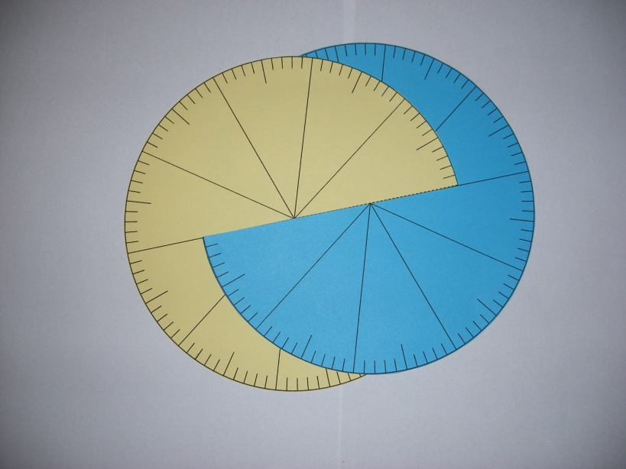
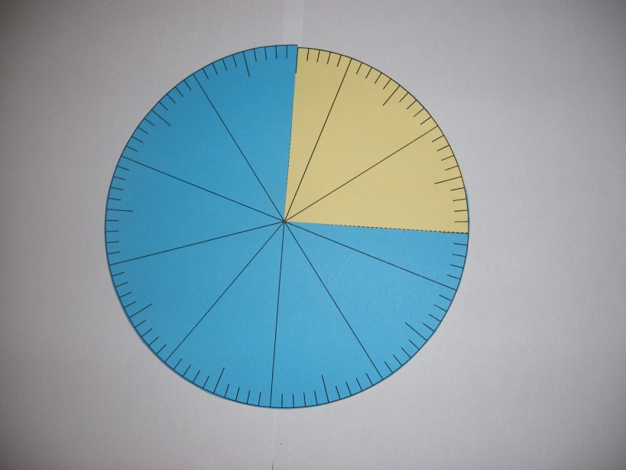

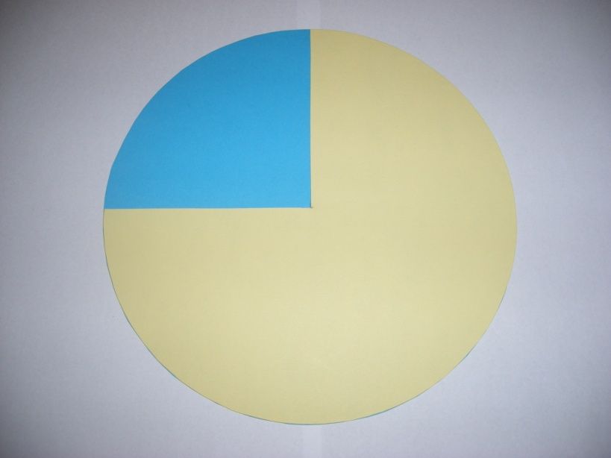

Student Activity 3
Disc with 100 divisions
Print out this circle twice on two different coloured sheets of card.
Cut out the circle shapes from the card and cut along the dashed line.
Slide one disc in over the other at the cut dashed line.
Use the2 discs together to estimate decimal equivalents of fractional parts and then turn over the discs to read exact values.

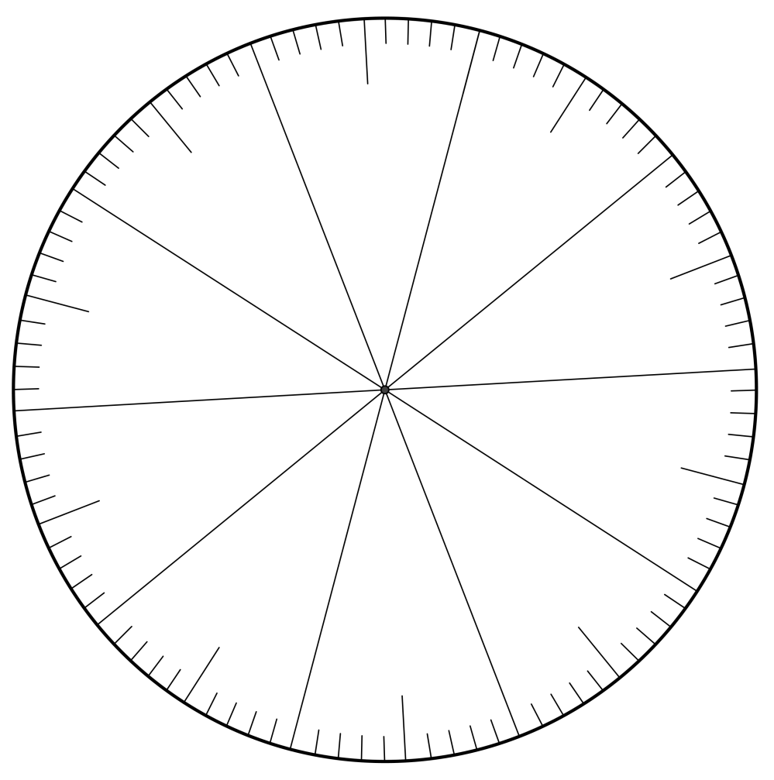

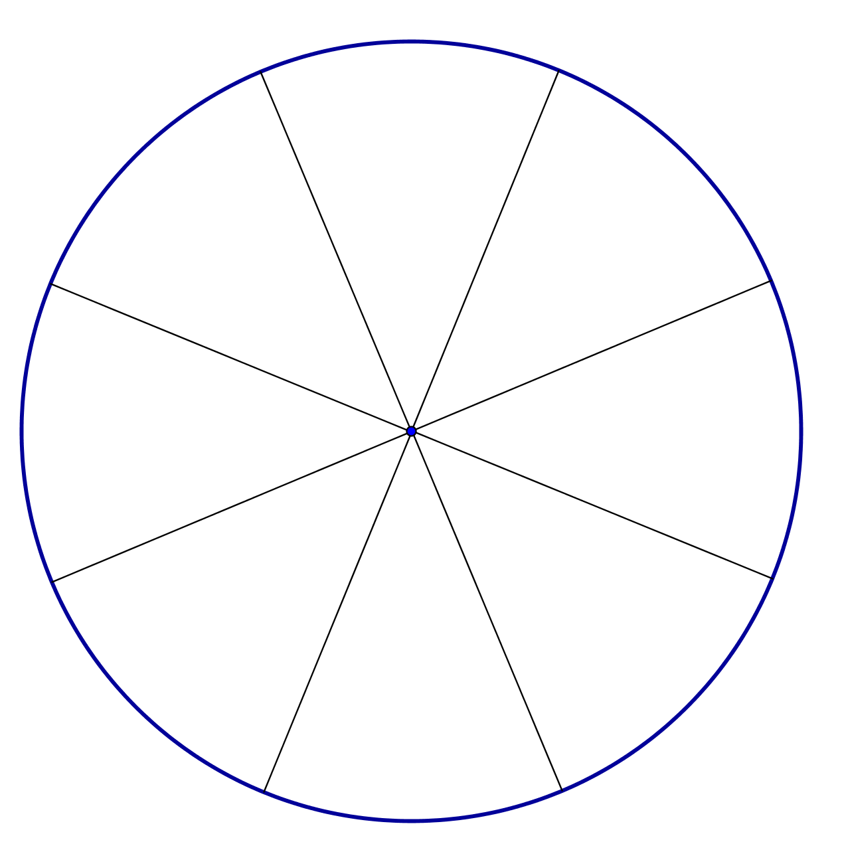
An eights disc (the same size as the previous hundredths disc) which can be meshed with the hundredths disc to give the number of hundredths equivalent to any number of eights from 0 to 8.
Student Activity 4
Represent each decimal on the 10 x 10 grid and on the numberline
1.
0.7
Write as a fraction also
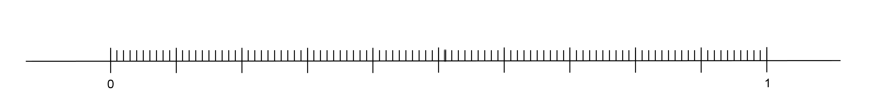
0.34
Write as the sum of 2 fractions

Write as a single fraction
0.495
Write as the sum of 3 fractions

Write as a single fraction

Follow on fractions and decimals activity.
A whole one | What is the bottom number in a fraction? | Denominator | What is 0.8 as a fraction?
8/10 | What is an equivalent fraction to 5/8? | 10/16 | What is a 0.5 as a fraction?
1/2 | What has a whole number and a fraction? | Mixed Number | If I cut a cake into fifths, how many pieces will I have?
5 | What is 9/4 as an improper fraction? | 2 ¼ | What is ¼ as a fraction?
0.25 | What is the top number in a fraction? | Numerator | If I cut a cake into tenths, how many pieces will I have?
10 | What is ¾ as a decimal? | 0.75 | What is 13/5 as a mixed number?
2 3/5 | What is an equivalent fraction to 90/100? | 9/10 | If I give 4/10 of a cake to a friend, how much do I have left?

6/10 | If I cut a cake into ninths, how many pieces will I have? | 9 | What is the name of a fraction which is worth the same, but has different numbers?
Equivalent | What is 4 ¼ as an improper fraction? | 17/4 | What is another word for divide?
Share | Which is larger? 1/4 or 1/5? | 1/4 | If I give 5/12 of a cake to a friend, how much do I have left?
7/12 | What is 2/10 as a decimal? | 0.2 | What is 9/10 as a decimal?
0.9 | What is an equivalent  fraction to ¾? | 9/12 | What does the denominator tell you?
How many parts something is cut into | Which is smaller? 2/3 or 2/6? | 2/6 | What is ¼ as a decimal?
0.25 | What is 13/8 as a mixed number? | 1 5/8 | How many fifths are in a whole?
5 | How do you know if a fraction is improper? | There is a larger number on the top | What is a 0.5 and 0.5?

Homework : Q1. Explain using the 10 x10 grids which fraction is greatest.
Which is greatest 0.5 or 0.055?_________ |  | Explain which is bigger
Show 0.5 on the grid | Show 0.055 on the grid
Which is greatest 0.245 or 0.25? _____ |  | Explain which is bigger
Show 0.245 on the grid | Show 0.25 on the grid
Which is bigger 0.098 or 0.980?_____ |  | Explain which is bigger
Show 0.098 on the grid. | Show 0.980 on the grid.
Q2. Imagine the following decimals on a 10 x 10 grid.
Describe each of them and then order them from smallest to largest: 0.375 0.36, 0.4, and 0.058
Base 10 model
Base 10 model with a “flat” for a unit, a “rod” for 1/10 and small cubes for hundredths
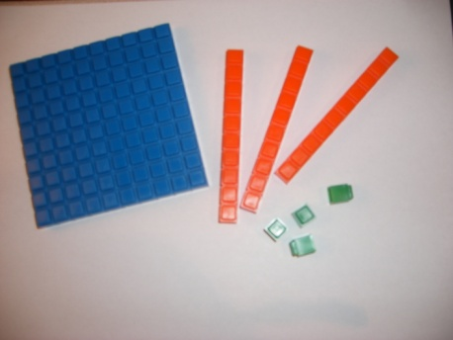

Below is a possible sample of a wall poster highlighting place value in the decimal system

34582.8371

1’s place
10’s place
100’s place
1000’s place
10000’s place
1/10’s place
1/100’s place
1/1000’s place
1/10000’s place
Decimal point

