Teaching and Learning Plan – Enlargements
Title of Class: Enlargements
Lesson Number: 2
Length of Lesson: 75 Minutes
Level of Class: Leaving Certificate.
Previous knowledge and experience of the material: From previous topics the students are aware of similar shapes. They would need to be able to construct rectilinear shapes (triangles and rectangles), and they would also need to understand the concept of ratios. Note rectilinear shapes are objects made up of straight lines.
Prior Knowledge:
Capable of constructing triangles, squares and rectangles
Knowledge of similar triangles

Aim of the Lesson: To introduce the topic of enlargements and enable students to accurately construct an enlargement of a rectilinear figure by deducing the ray method.
Objectives:
- To enable students to explain and identify the concept of an ‘enlargement’ and to recognise associated terms.
- To enable students to identify similar shapes.
- To enable students to construct the rays on two similar shapes and hence calculate the centre of enlargement and the scale factor.
- To encourage and enable students to investigate and conclude that if the length of the sides of one triangle is k times the length of the other, that the scale factor is also k.
Subject Matter:
- Centre of enlargement.
- Image and Object
- Scale Factor.

Relationship to Junior Certificate Syllabus

Students learn about | Students working at FL should be able to | In addition students working at OL should be able to | In addition students working at HL should be able to
2.4 Transformation geometry, enlargements | - investigate enlargements paying attention to  - centre of enlargement  - scale factor k ;0<k<1 ,  k >1 k ε Q  - area  - solve problems involving enlargements

Resources required:
- Coloured card (Suggestion scrapbook with a variety of colours.)
- Scissors
- Math sets
- Poster paper
- Glue
- Long Rulers
- White board and marker
- Worksheet (See Appendix A)
- Demonstration triangles
- Russian Dolls
- Photographs (Same photo, but printed in different sizes)
- Also possible items from supermarket where small and large packages are examples of enlargements, for example Toblerone bars, cereal boxes, toothpaste boxes
- 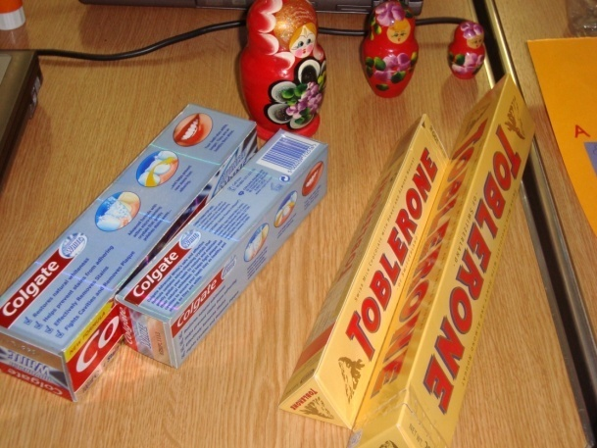

Pre-preparation
Cut scrap book sheets in half and write on each half sheet instructions re sizes of triangles, squares or triangles you require the students to produce. Note make sure these are given out in pairs as listed below:
 | Shape 1 | Shape 2
Pair 1 | Triangle angles 45⁰, 65⁰ and side 9 cm | Triangle angles 45⁰, 65⁰ and side 12 cm
Pair 2 | Triangle angle 50⁰ and sides 9 cm and 6 cm | Triangle angle 50⁰and sides 9 cm and 12 cm
Pair 3 | Triangle angle 100⁰, 65⁰ and sides 7 cm and 6 cm | Triangle angle 100⁰and side 14 cm and 12 cm
Pair 4 | Triangle angles 45⁰, 65⁰ and side 9 cm | Triangle angles 45⁰, 65⁰ and side 9 cm
Pair 5 | Triangle angles 70⁰, 70⁰ and side 8 cm | Triangle angles 70⁰, 70⁰ and side 16 cm
Pair 6 | Triangle sides 5 cm, 6 cm and 7 cm | Triangle sides 10 cm, 12 cm and 14 cm
Pair 7 | Triangle sides 9 cm, 12 cm and 15 cm | Triangle sides 12cm, 16 cm and 20 cm
Pair 8 | Triangle angles 60⁰, 60⁰ and side 8 cm | Triangle angles 60⁰, 60⁰ and side 16 cm
Pair 9 | Square 8 cm by 8 cm | Square 16 cm by 16 cm
Pair 10 | Rectangle 8 cm by 6 cm | Rectangle 16 cm by 12 cm

Lesson Interaction
Student Learning Tasks:  Teacher Input | Student Activities: Possible and Expected Responses | Teacher’s Support and Actions | Checking Understanding
Task 1  Arrange students into pre-decided pairs, based on ability, (strong student with a weak student). Students are unaware at this stage, who their partner is.  Distribute paper, math instruments and scissors to each student. |  | Ensure that clear and definite instructions are given at the start of the lesson so as to avoid confusion and unnecessary questions.
Task 2  Give each student a pre-prepared scrapbook sheet with the dimensions of the triangles etc. written on them. Put half the class making smaller dimensions (Shape 1) and the other half the larger dimensions (Shape 2), so as to ensure that students are not aware of the concept too early on. Demonstrate and re-cap on the method of construction, if necessary. | Questions regarding the method of construction. | Allow students time to construct the shapes. Walk around the classroom observing the work being carried out and offer help as required. | Are students drawing sides of the figures, and measuring the angles to the exact dimensions given?
Task 3  Find another person in the room who has the same coloured sheet. Prompt students to relate that the angles are the same but that one shape is bigger than the other. | Some students in the class recognize that the shapes of the corresponding figures are the same shape but different in size. | Get the students to find another person in the room who has the same coloured sheet and offer help to those who cannot find their partner.  Encourage students to examine the shape they have constructed, comparing and contrasting both shapes and hence motivate students to deduce that the triangles or rectangles are similar in shape. | Do students understand the concept of similar shapes?
Task 4  Show students the Russian Dolls, Photographs and supermarket items to further reinforce and demonstrate the theory point and elicit the term enlargement from the pupils themselves. | Students said various terms relating to the concept enlargement. | Use all of the props to reinforce the concept of enlargement.  The photographs were the best resource when eliciting the term enlargement – students could link the concept best to this resource.  Draw the students’ attention to the situation where the scale factor is less than 1. | Do students understand what is meant by an enlargement in terms of the props provided?
Task 5  Distribute poster paper to each pair of students. Label the smaller shape A, B, C and larger shape (the image) A1, B1, C1. Get each pair of students to stick on their shapes as on the Sample Activities on Page 9 of this T&L.  Join the points AA1, BB1, and CC1 and continuing these lines until they intersect. | The students may have difficulty understanding what the lines mean and this may require further discussion and explanation. | Question students to predict the result of joining the corresponding points AA1, BB1, CC1 and continuing these lines until they intersect. Clarify any misconceptions that students may have. | Students required help in positioning the figures (Object and Image) on the poster, and choosing a centre of enlargement.
Task 6  Demonstrate the calculation of the scale factor and introduce the concept of the centre of enlargement. Allow students time to construct the centre of enlargement on their own shape, and hence compute the scale factor on their poster. | Some students struggled with this task initially. They needed to repeat the measurement of the distances between the centre of enlargement to the object and to the image before they recognized any relationship. Stronger students deduced the relationship between the area of the object and the image at this point. | Monitor the class and aid students where difficulty arises encouraging them to complete the task. | Reinforcement of the need for accuracy when measuring distances was required.
Task 7  Handout the worksheet (See Appendix A) to re-cap on the topic and to reinforce the learning that has taken place. Alternatively see Internet resources on page 9. | Students read the worksheet questions and asked for further clarification where needed. | Re-cap on formulae and definitions needed for the exercise in order to aid learning, e.g. Scale Factor = Image Length / Object Length.  Draw the students’ attention to the situation where the scale factor is less than 1. | Do all students understand what is meant by the centre of Enlargement and how the scale factor is calculated?
Homework: Complete the worksheet to reinforce the learning.

N.B. This T&L does not cover the following aspect of the Transformation geometry, enlargements section of the Leaving certificate syllabus:

- Area.
Internet Resources Further exercises http://www.bbc.co.uk/apps/ifl/schools/gcsebitesize/maths/quizengine?quiz=transformationshigher&templateStyle=maths

http://www.channel4learning.com/support/programmenotes/netnotes/content/pdfs/m4r/m4r2ws10.pdf

Sample Activities
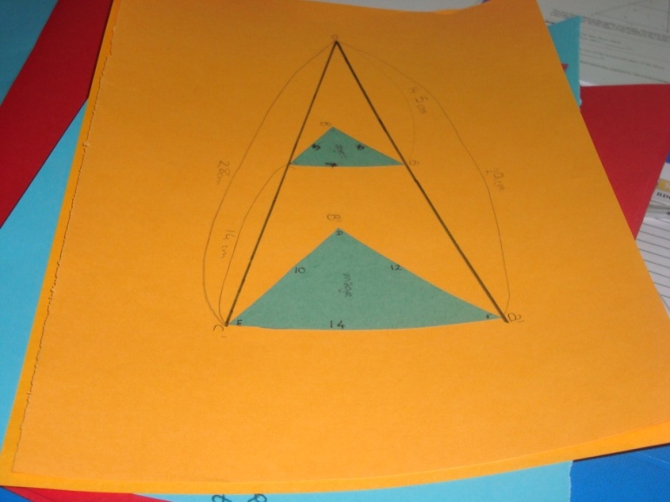
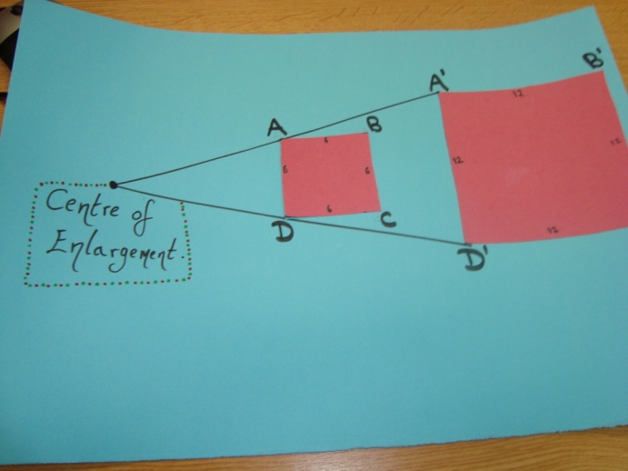

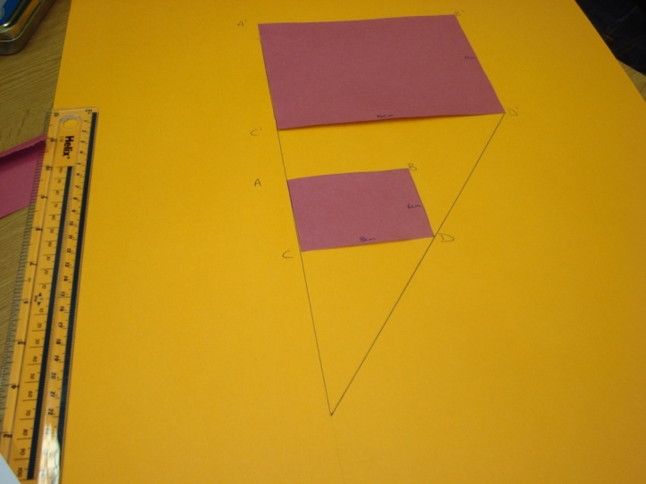

Appendix A Worksheet
- In the following diagram A’B’C’ is the image of ABC under an enlargement with centre D and scale factor 2. If AB = 1.5 cm, BC =1.6 cm and AC= 1.8 cm, find lengths of A’B’, B’C’ and A’C’. Show calculations.

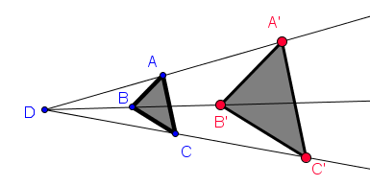
- Show the image of ABC under an enlargement with centre D and scale factor 3.

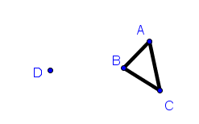

- If A’B’C’ is the image of ABC and the scale factor is 4, find D the centre of enlargement.
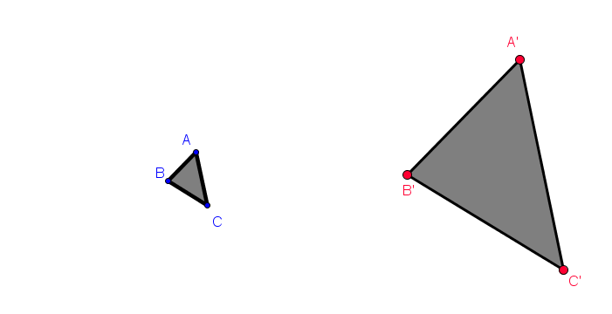

- Find the image of ABC, if B is the centre of enlargement and the scale factor is 2.

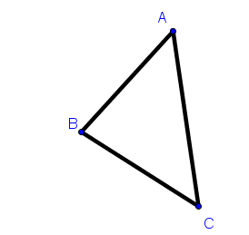

- Find the image of ABC by a scale factor of ½, if the centre of enlargement is D.
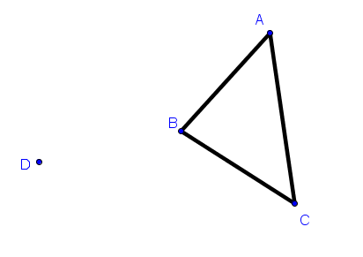
- If ABC is 85⁰ and ACB is 35⁰, complete the following table.
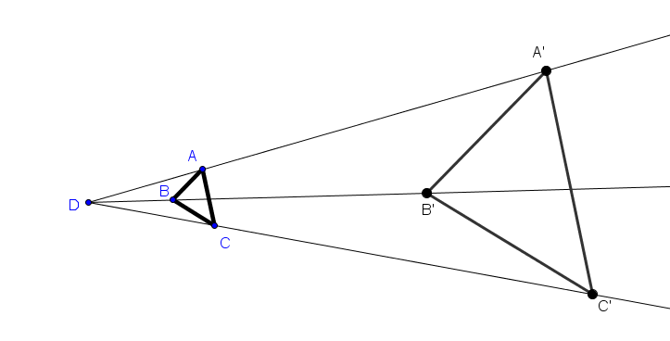
BAC
A’B’C’
A’C’B’
B’A’C’

- © www.teachers.tv/system/files/13223_01.pdf

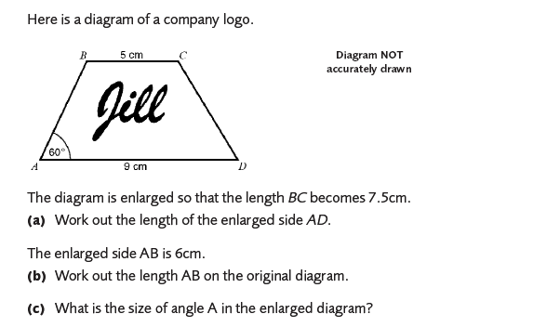
- © www.teachers.tv/system/files/13223_01.pdf
