
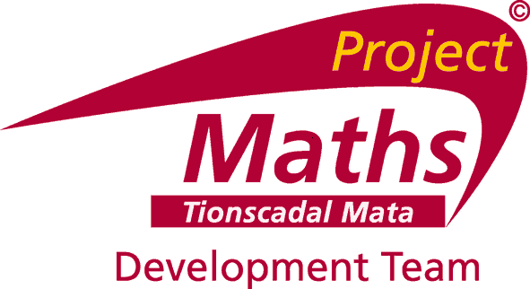


Application form for Associate Positions

Project Maths Development Team (PMDT)

Name of Applicant: _________________________________________________________________________

REGIONS

Please identify your region by ticking (√) the appropriate region:

REGIONS |  | Please identify your region (√).
1 | Cavan, Monaghan, Louth, Meath & North Dublin
2 | South Dublin, Kildare, North Wicklow
3 | Wexford, Waterford, Carlow, Kilkenny, South Wicklow & South East Tipperary
4 | Cork, Kerry, Limerick & North West Tipperary
5 | Clare, Galway, Laois, Offaly, Westmeath, South Roscommon & North East Tipperary
6 | Mayo, Sligo, North Roscommon, Leitrim, Donegal & Longford

- An electronic completed application form must be submitted by 5pm 8th May 2015 to grainneh@ecdrumcondra.ie
- Receipt of completed application forms will be acknowledged.

Office Use Only: Date Received: ___________________________________________________________

Application No: ___________________________________________________________

1. Personal Details:

Name
Address
Teaching Council No. |  |  | PPS No. |  |  | PRSI Class
Telephone Numbers |  | Home: |  |  | Mobile:
E-mail
Driving Licence  (Please √ as appropriate) |  | Full Licence Provisional Licence

2. Current Employment Status:

School

School Address

Principal’s Name
Employment Status | □ PWT |  | □ Part-time |  | □ Retired |  | □ Other (please specify)  ________________________
Roll Number |  |  |  | Telephone Number
Position (i.e. Principal, Deputy Principal, Classroom Teacher, Class/Learning Support Teacher, etc)  Other (please specify)  ________________________ |  |  |  |  |  | Category (please tick)  Post-primary  Special School  Irish-medium school |  | □  □  □
If Post-holder, please
specify duties

If retired please state the date of retirement

Month □ Day □ Year □

3. Competency in Irish: Please indicate by ticking (√) a box as appropriate

Very good: ◻ Good: ◻ Fair: ◻ Poor: ◻

4. Qualifications (including post-graduate)
Full title of Degree(s)/  Qualification(s) held | Major Subject(s) | Awarding Body | Year | Grade obtained | NFQ Level

5. School Leadership/Teaching Experience

Position (Title/Subject/ Programme/ Learning Support etc.) | Responsibilities/Subjects taught  (include details of year groups and levels taught) | School Name(s) | Years

6. Affiliation with professional groups/teacher networks
Professional Group/ Teacher Network | Brief Details of Role | Years

7. Briefly outline your involvement in/engagement with curriculum and assessment development and innovation in classrooms

8. Provide details of your experience and main achievements in the organisation / design / delivery of continuing professional development (CPD)

9. Are you already seconded to /engaged as an associate or local facilitator with another support service or organisation? Yes ◻ No ◻

If yes, please give the name and address of the organisation
10. Please include the contact details of two educational referees who may be contacted by PMDT in relation to the details provided on this application form (e.g, principal, deputy principal, education centre director, or support service personnel)

(a) Referee 1

Referee’s Name
Position held
Organisation
Address
Mobile Number
E-mail Address

(b) Referee 2

Referee’s Name
Position held
Organisation
Address
Mobile Number
E-mail Address

Drumcondra Education Centre reserves the right to seek additional or alternative referees if deemed appropriate by the selection panel.

I hereby certify that all information provided on this application form is true and correct:

Signature of Applicant: _______________________________________________

Date: _______________________________________________

PLEASE NOTE
This information will be included on a central database managed by Drumcondra and Blackrock Education Centre on behalf of the Department of Education and Skills. In the event that other Department of Education Support Services or Education Centres wish to access your information in order to access suitably qualified/skilled personnel for work on their behalf, do you give permission for your information to be shared with such Support Services?
Yes
No
DATA PROTECTION: PMDT & Blackrock Education Centre will treat all personal data you provide on this form as confidential and will use it solely for the purpose intended. The information will only be disclosed as permitted by law or for the purposes listed in the Blackrock Education Centre registration with the Data Protection Commissioner - REF 10764/A. If the information you have provided is to be used for purposes other than outlined in Blackrock Education Centre’s registration with the DPC your permission will be sought.

