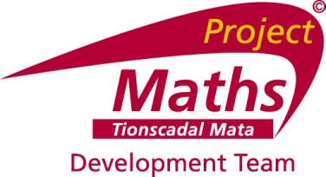

**Project   
 Maths**

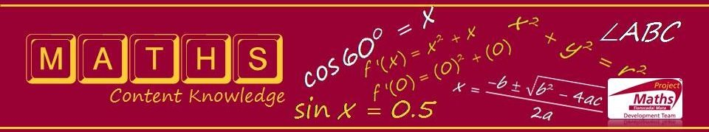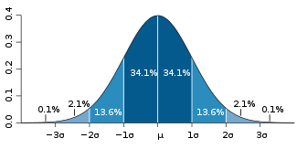

**P(A  B) = P(A) x P(B|A)**

**correlation = ± 1**

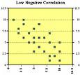

**Stem & Leaf Plots**

**Data Handling**



COMMENCING APRIL 2010 IN A CENTRE NEAR YOU …

Local Courses on Content Knowledge for Strand 1: Statistics and Probability

* For teachers of Junior and Senior Cycle mathematics (all levels)
* 5 modules of 2.5 hours each
* Using DVD and resources based on NCE-MSTL summer course
* Delivered by experienced maths teachers
* Attendance will be certified

**Education Centre: Start Date:**

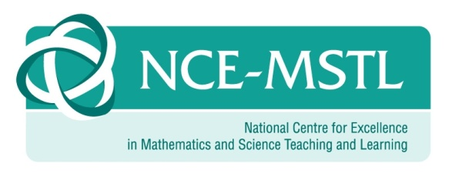

|  |
| --- |
| **The Project Maths Development Team, in collaboration with the National Centre of Excellence in Maths and Science Teaching and Learning in the University of Limerick , is pleased to offer this course on Strand 1: Probability & Statistics. The workshops will focus on new elements of the course, methodology and the use of information technology and will cover topics from Junior Certificate and Leaving Certificate. For a full course description go to** [**www.projectmaths.ie**](http://www.projectmaths.ie)**/news** |

For a full course description go to [www.projectmaths.ie](http://www.projectmaths.ie)/news/