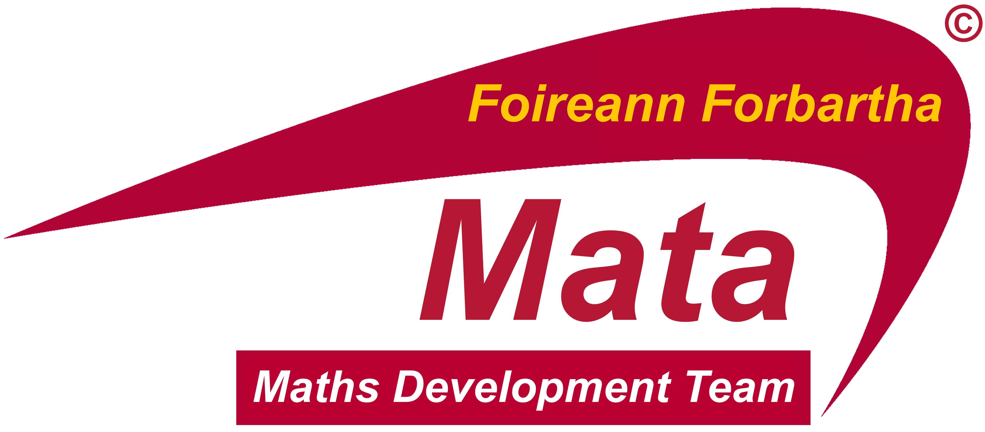

18TH May 2017

Dear Principal,

The Maths Development Team is currently planning half day school visits/repeat school visits to support the on-going professional development of teachers engaged in Maths Development during the next school term. It should be noted that teaching and learning and in particular:
- Algebra through the Lens of Functions
- Geometry through the Lens of Enquiry
will be the focus of any such visit through teachers reflecting on practice and learning in these areas. The major goals of the school visits are to help teachers:
- Recognise key mathematical ideas with which students are having difficulty.
- Gain insights into students’ thinking.
- Develop questioning that will help students deepen their mathematical understanding.
- Analyse tasks to discover the mathematics content students will learn from engagement with.
- Make more mathematical connections.
- Reflect on current department practices and school-based initiatives.
Please note that teachers’ attendance at school visits is not approved for the purposes of substitution.
Any school-identified need in addition to Algebra and Geometry will be accommodated.
If you wish to apply for a member of the team to visit your Maths Department during 2017-2018 school year, please complete the accompanying form and return/email to: Maths Development Team, Drumcondra Education Centre, Drumcondra, Dublin 9 OR email: grainneh@ecdrumcondra.ie or racheld@ecdrumcondra.ie by Friday, 2nd June 2017.

To assist your school in planning for a visit, a date will be allocated to your school as soon as possible. All school visits will take place from 9.30am – 1pm.

Thank you for your time and co-operation. It is greatly appreciated.

Yours sincerely

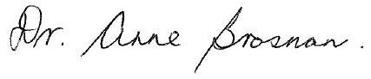
___________________________
Dr. Anne Brosnan
National Co-ordinator, Project Maths Development Team

Please note that the Maths Development Team has no role in relation to syllabus, examinations, sample papers, or marking schemes. Queries in relation to the examinations should be directed to the State Examinations Commission, using the contact form on the SEC website. Syllabus queries should be directed to the NCCA at projectmaths@ncca.ie. School visits are for the purposes of providing support based on teaching and learning.

PLEASE COMPLETE REGISTRATION BELOW IF YOU WISH TO AVAIL OF A
SCHOOL VISIT

School Roll No.
School Name:
Principal Name:
Maths Co-Ordinator contact name:
Maths Co-Ordinator Mobile no:
Maths Co-Ordinator email:
Number of teachers in Maths Dept.

Signature: Date:

Principal/Deputy Principal

