**You know a lot about fractions already  
 --------- but please read carefully before answering**

Did you know that 5 out of 4 people don’t understand jokes about fractions?

1. The circle below represents a cake.  of the cake has been eaten. How much of the cake is left? ________________

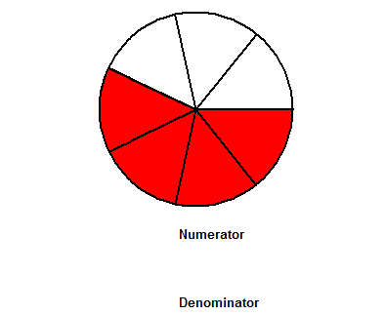

2. Estimate how much of the rectangle below is shaded.

(i) Between 0 and (ii) between (iii) between (iv) between 

|  |  |  |  |  |  |  |
| --- | --- | --- | --- | --- | --- | --- |
|  |  |  |  |  |  |  |

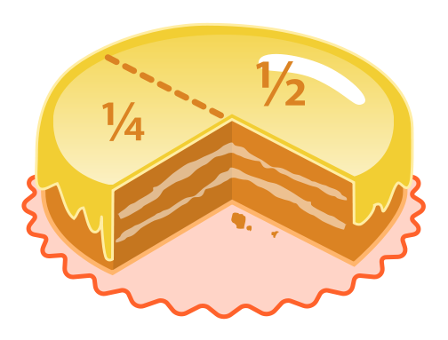 Answer______________________________

3. Here is a number line. Mark 2on the number line.

|  |  |  |  |  |
| --- | --- | --- | --- | --- |
|  |  |  |  |  |

0

1

2

3

4

5

4. Show the fraction three – fifths in two different ways.

5. How many sixths in a whole? ______ Draw a diagram to show this.

6. What fraction of the heart shapes are upside down if is taken to be the right way around? Write your answer in two different ways.

**Answers** _**______ _______**

How do we know that the following fractions are not in Ireland?

x/c, y/c, z/c

A. Their numerators   
are all over c’s!!!

[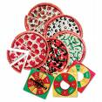](http://www.learningresources.com/images/en_US/local/products/detail/prod5061_dt.j)7. Explain in your own words what a fraction is.

______________________________________________________________________________

8. Choose any fraction. Show how you would explain to your friend what this fraction means using a drawing of one object or a collection of objects.

9. Do you like learning about fractions? ____________________________________

Do you find them easy to understand? ____________________________________

10. Why do you think you need to learn about fractions?

_______________________________________________________________________________________________________________________________________________________________________________________________________________

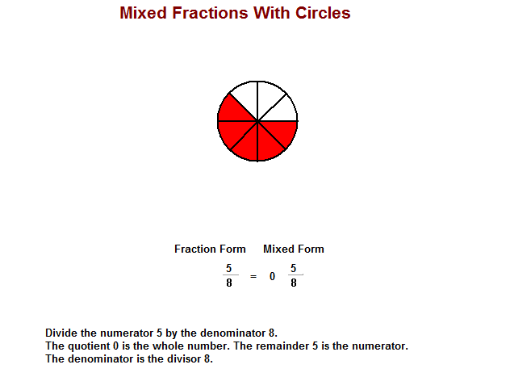11. Do you know of any other parts of the Maths course which are really fractions but are called by other names?

______________________________________________________________________

(Think for example of when there are sales on and you get reductions. They don’t usually say 3/10 off. What do they say? We also don’t usually say €10 ½ when doing calculations with money. What do we say?)

[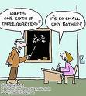](http://images.google.ie/imgres?imgurl=http://www.webcampus.co.uk/stc/file.php/444/Images/fraction.jpg&imgrefurl=http://www.webcampus.co.uk/trafford/course/view.php?id=444&usg=__kkx6HRlHMsqP16Q9RNeBH-XsQ3s=&h=400&w=357&sz=25&hl=en&start=4&tbnid=uDHdmJCVGlPubM:&tbnh=124&tbnw=111&prev=/images?q=fractions&gbv=2&hl=en&safe=o)12. Write down briefly some of the things you learned about fractions in primary school.

13. Which of these rectangles is not divided into four equal parts?

(i) (ii) (iii) (iv)

**Answer ______________**

14. Which of these rectangles has  shaded in? Is it more than one rectangle?

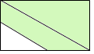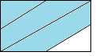(i) (ii) (iii) (iv)

**Answer: _________**

15. Kate gave of her pocket money to charity. Joe gave of his pocket money to another charity. Joe said that he gave more money to charity than Kate did. Explain how Joe could be right.

__________________________________________________________________________________________________________________________________

16. Students were asked to explain why is greater than. Which of the following explanations is the correct one?

1. Because 5 is greater than 4
2. Because 6 is greater than 5
3. Because 5+6 is greater than 4+5
4. Because is closer to one than 

**Answer: __________________________________**

17. Which of these fractions is smallest?

(i)  (ii)  (iii) (iv) **Answer: ____ Explain_______________________________________________________________**

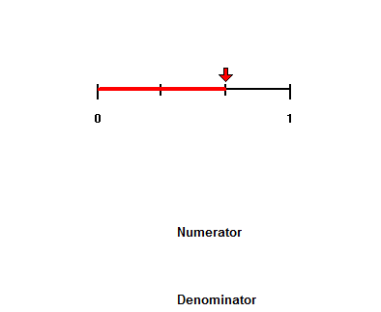18. Below are 3 number lines all of which are the same length.

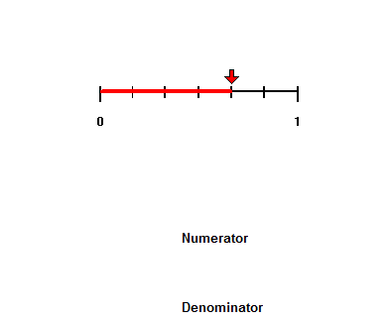This number line shows shaded.

What fraction of this number line is shaded? __

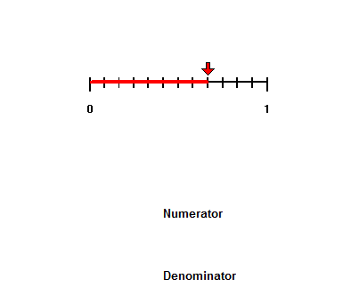

What fraction of this number line is shaded? __________

19. What do the fractions in question 18 have in common?

_________________________________________________________________

20. The following diagrams represent 2 pizzas of the same size. You ate the shaded amount in the first pizza which is divided into 5 equal parts and your friend ate the shaded amount of the second pizza.

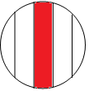 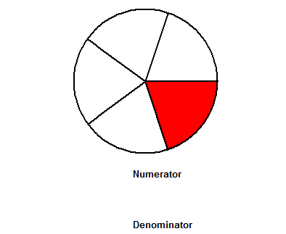

Did you both eat the same amount of pizza? ____________   
Explain your answer. ______________________________________________________________________________

21. Circle  of these shapes.

22. How many **sixths** are shaded in the following diagram? 

23. What fraction of the circle is part “f” in the following diagram? _________

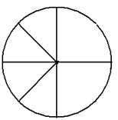

a

f

b

e

c

d

24. John cuts a pizza into 12 slices. He then gives  of the pizza to his friend Peter. How many slices of pizza does Peter get? ________________________

Draw a picture to show how this problem could be solved.

25. The following diagram shows of a courtyard which is being covered with tarmacadam.

Modify the picture to show the whole courtyard.

Explain why the diagram now shows the entire courtyard.

­­­­­­­­­­­­­­­­­­­­­­­­_____________________________________________________________________________

26.

A. If the shaded portion represents, what is the unit?

B. Using the same unit what would 6 small rectangles represent?__________________

C. If 3 shaded rectangles represented a unit, what number would be represented by the total number of shaded rectangles?_________________

D. List some other numbers that the shaded portion could represent and give the unit in each case.

|  |  |
| --- | --- |
| Number represented by the shaded rectangles | The number of squares = one unit |
|  |  |
|  |  |
|  |  |
|  |  |
|  |  |

27.

The shaded part of this diagram could represent the numbers

**A**: 5 **B**:  **C**:  **D**: 

Identify the **unit** in each case by drawing:

A: B: C: D:

28. +=

29. =

30. +=

**HOMEWORK**

1. Laura has 8 cookies to share between herself and her 5 friends. Using the pictures of the cookies below, **describe and model** how she can share out the cookies so that each person receives the same amount. How much does each person get?
2. Oliver had 5 chocolate bars to divide among 8 people. How much of a chocolate bar did each person get if they all got fair shares?   
   Describe and model how the bars are shared out?
3. 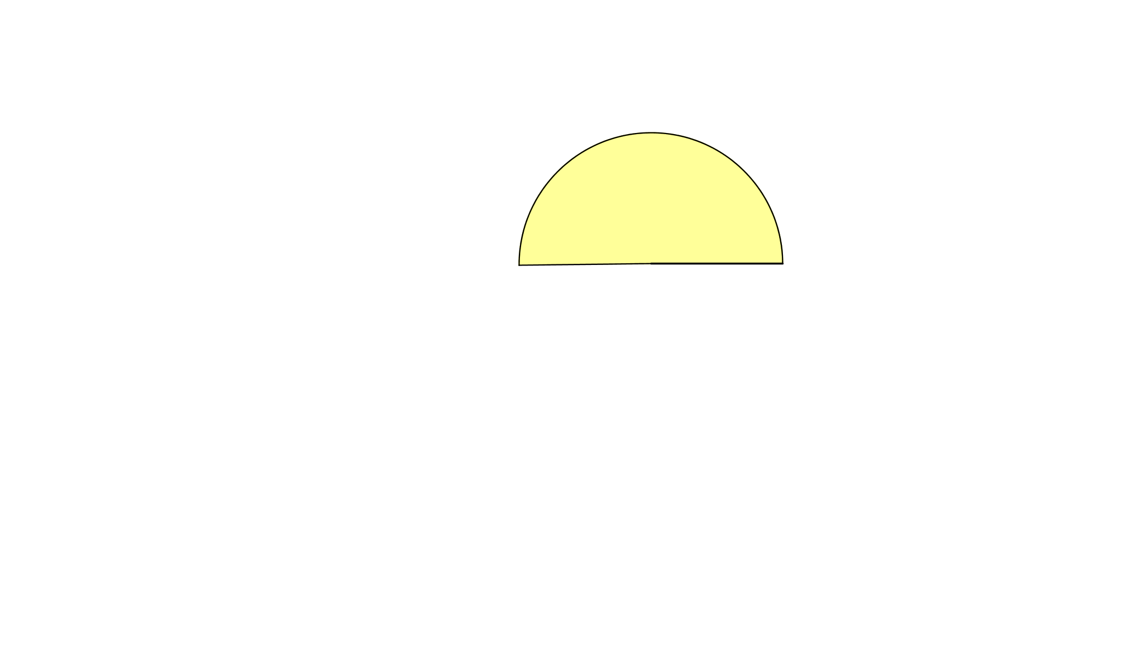 The shaded area below represents of a patio area. What shape would represent the whole patio?