Task 1.1 – Modelling

A bank offers a yearly compound interest rate of 20%. Paul wishes to invest €100. What will the value of this investment be at the end of n years?
Each Box represents €10, colour in Paul’s initial investment.
In a different colour, add in his interest received after 1 year.

Now repeat the steps above using the same two colours but also add in his interest received after 2 years in a new colour. (Any fractional parts should be represented by a partially completed box)

Repeat the above steps adding in his interest received after 3 years.

What do you notice about the pattern?

Fill in the blanks.
This is a/an __________ sequence with a common ____________ of ________.

In the orange boxes provided, write an expression to describe each of John’s investments in the form ${€100 x 1.2}^{t}, t ϵ N$.

Complete the table to represent Paul’s investment for the first five years.
Year | Starting Amount | Interest | Total Amount  at end of year
1 | 100 | 100 x 0.2 = 20 | 100 + 20 = 120 | 100 + 100 x 0.2 | 100(1 + 0.2)
2 | 120 | 120 x 0.2 = 24 | 120 + 24 = 144 | 120 + 120 x 0.2 | 120(1 + 0.2)
3
4
5

Complete the following table:
Year | Starting Amount | Total  Amount
1 | 100 | 100(1 + 0.2) | 100(1 + 0.2) | 100(1 + 0.2)
2 | 120 | 120(1 + 0.2) | 100(1 + 0.2)(1 + 0.2) | 100(1 + 0.2)²
3
4
5

Can you predict the amount the investment is worth at the end of n years?

Additional Notes

Task 1.2 – Investments
Jenny wishes to invest some money. She invests €20 at the start of each month for five months, in a savings account which offers a monthly rate of 0.5%. What will the value of this investment be at the end of five months?

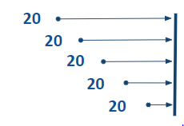

Task 1.3 - Modelling
Jenny wishes instead to invest her money for 5 years She invests €20 at the start of each month for five years, into a savings account which offers a monthly rate of 0.5%. Model this investment as a group of individual deposits.

Task 1.3 - Extension
Jenny invests €20 at the start of each month for three years. She then reduces her investment to €15 for the remaining two years. What will the value of this investment be at the end of five years?

Task 2.1 – Multiplication of Integers

A is a natural number. If B is a positive integer, what is the effect on A of multiplying by B? Describe the effect of multiplication on A with particular reference to the location of the product and the scale factor.

Describe the effect of multiplication on a real number by another real number. Refer to the scale factor, location and rotation.

A is an integer, B= -3 What is the effect on A of multiplying by each of the following?
Problem | Rotation | Number of rotations | Scale factor
A x (-3)¹ | 180° | 1 | 3
A x (-3)² | 180° + 180° | 2 | 3²
A x (-3)³
A x (-3)⁴
A x (-3)⁵

What is the effect of raising A to the power of n?

A is an integer, B= -1 What is the effect on A of multiplying by each of the following?
Problem | Rotation | Number of rotations | Scale factor
A x (-1)¹
A x (-1)²
A x (-1)³
A x (-1)⁴
A x (-1)⁵

What would be the effect of multiplying A x (-1)^{1/2?}

If A = 1, B = A x i, can you suggest a suitable position for B on the diagram below?

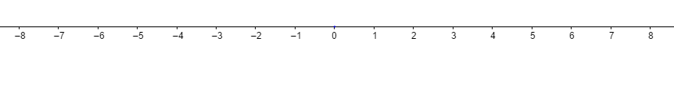

Notes

Task 2.2 – Multiplication of Complex Numbers

Open the GeoGebra file:
https://tinyurl.com/WS4task2-2
z₁ and z₂ are complex numbers with a product z₃. By moving z₁ and observing z₃ consider the effect on z₁ of multiplication by z₂. Use the check boxes to support this investigation.
Can you suggest in words a rule for multiplying complex numbers?

Extensions
Exponents and complex numbers.
z₁ = -1+i is a complex number with a modulus of $√$2 and argument of 135$°$. By setting z₁ = z₂ = -1+i, now z₃ = (-1 + i)². Describe the effect of squaring z_{1,} referring to the moduli and the angles.

Can you describe the effect on a complex number z, of raising z to the power of n?

Task 2.3 Addition of Complex Numbers
https://www.geogebra.org/classic/hapyyrhd
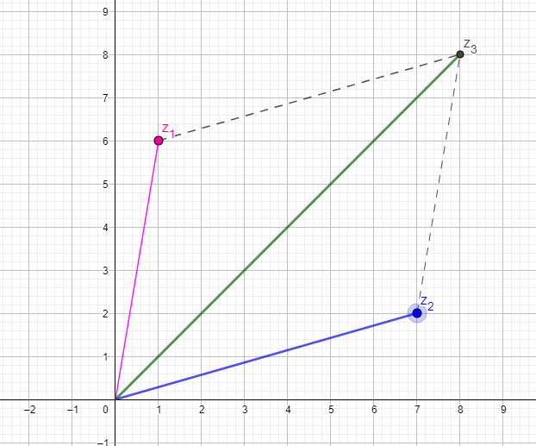

Task 3: Take Home Task

This task should be approached from the perspective of a higher level 5th year student.
Student Prior Knowledge:
- JC Number Operations
- Modulus of a complex number
- Multiplication of complex numbers using modulus and angles.

Link to Syllabus (LC OL):
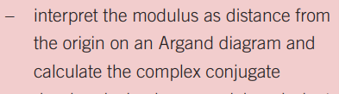
Link to Syllabus (LC HL):
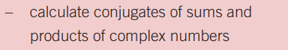

Investigation 3.1
Open the GeoGebra file “complex Conjugate”
https://tinyurl.com/WS4Takehome

z₁, z₂ and z₃ are complex numbers. Move z₁. What is the effect on z₂ of moving z₁?

z₃ is the product of z₁ and z_{2.} Why does z₃ always lie on the real axis?

Click the checkbox |z|.
Choose a value for z₁, and record the modulus of z₁, z₂ and z₃.
Repeat this process with a different value for z₁.
Can you describe the relationship between the moduli?

Click the checkbox “Angle”
Change the position of z₁ and note the effect on the angles α, β and γ.
Write down in words any relationship you can find between α, β and γ.

Why might this investigation help students to understand the role of the conjugate in complex division?

Investigation 3.2
Construct a line segment from z₁ to z_{2.}
What questions could you ask students to connect Pythagoras’ Theorem to the modulus of a complex number?

Using the trigonometric ratios, write down the coordinates of the point z₁ and z₂?
Why might this investigation help students understand their study of De Moivre’s Theorem?

Feedback
Please log onto:

https://tinyurl.com/WS4Home

and provide some feedback for this task.

