Real TY Modelling Task

Question: When is the best time to join the canteen queue at lunchtime?

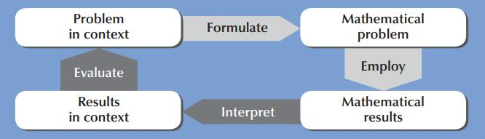

Questions for teachers to consider:
How would you give it a meaningful context for your TY students?
Could you collaborate with other teachers/departments(STEM or otherwise)/agencies to enrich the task?
How might students approach the task and how can they mathematise and generalise the situation?
What resources would help and what opportunities are there to use digital technology?
How will students be asked to present their work?

What assumptions do we need to make?
What approaches might a student take?
What support questions might we ask?
What extension questions can we ask?
What challenges for students may arise?

What is meant by the best time? - is it the least amount of wait time versus the time left to enjoy lunch?
What are the variables? - This is school dependent (for the purpose of this exercise the group could agree on a school population, no. of servers, no. of students who use the canteen)
How many students go for canteen lunch?
How many servers are there?
Do students arrive at the same time, or in clusters?
How long does each student take to be served?
What is the queuing discipline like?
- do students wait their turn?
- is there queue jockeying (moving between queues)?
- do students step out of the queue if it is too long (renege) and come back later?
- do students balk - see that the queue is too long and decide not to join?

Rationale:
The mathematics of queuing theory is more complicated than TY or even second level mathematics, however every student encounters a queue on an almost daily basis and therefore this type of problem could be modelled out and would be engaging for students. Here is a simple 2.5 minute video that simplifies queuing theory: https://www.youtube.com/watch?v=Yo7LG_JeJos

And an article from the RTE brainstorming website on queues for an airplane:
https://www.rte.ie/brainstorm/2019/0522/1050956-stand-in-from-the-aisle-heres-how-we-should-be-boarding-planes/

Approaches:
Draw a diagram
Collect data - from primary or secondary sources
Primary = physically going and counting students that go for lunch
Secondary = asking the office, or canteen manager for the numbers
Do the numbers of customers differ each day?
Use a timer to get the average amount of time each person spends getting served.
Calculate the rate of customers arriving.
Use these numbers to create a (proportional) formula (eg: Ave no. of customers = rate of footfall x time spent at server - Little’s Law https://toggl.com/littles-law/)
Would wait time fall into a particular distribution model?

Useful resources:
Stopwatch
Clicker for counting people

Alternative Task Outline
Look at 3 different routes to leave the school grounds at the end of the school day(e.g. from the maths room on the top floor to the front gate of the school)
Which is shorter? Faster?

Task with more details and ideas
Look at 3 different routes to leave the school grounds at the end of the school day(e.g. from the maths room on the top floor to the front gate of the school)
Which is shorter? Faster?
How long does each take:
- Alone?
- Walking with 1/2/3 friends?
Time allowed for stairs? Doorways?
What if your class is left out:
- First?
- Later?
- Last?

Possible Approaches
Distance/speed/time Pythagoras congestion
Formula: (Distance1$÷$ Speed1)+ (Distance2$÷$Speed2) + … + Delay1 + Delay 2+ ….

velocity-time graphs/motion sensor

Useful Resources
Map of school
Stopwatch
GPS watch

