Disease Spread
Unfortunately a member of your school community has contracted the contagious “schoolpox” disease.
The infected person doesn’t know they have the disease and come into school the next day (the first of the month).
Each day an infected person passes the disease onto 2 (R₀ = 2) other people in the school.
- Will everyone in the school get the disease?
- If so, when?

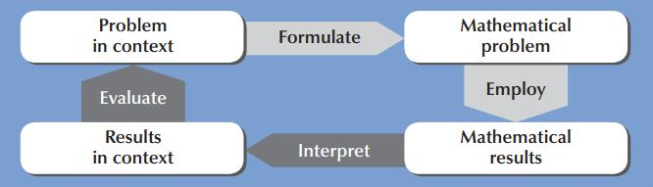

Your team will present your work to the: other TYs/5th year biology class/3rd science class

_________________________________________________________________________
- How would you give this a meaningful context for your TY students?
- Could you collaborate with other teachers/departments(STEM or otherwise)/agencies to enrich the task?
- How might students approach the task and how can they mathematise and generalise the situation?
- What resources would help and what opportunities are there to use digital technology?
- How will students be asked to present their work?
_________________________________________________________________________

Possible Questions to develop the model
When an infected person passes the infection, are they still infected themselves?
Will people stay infected forever?
(If so, then everyone on the planet will be infected in 21 days!)
If the disease only stays in someone’s system for 7 days, how does this affect the spread?

On the third day of having “schoolpox” the sick person comes out in spots and students are told to stay out of school if they have these spots. How does this affect the spread?

Does it matter if the first person infected is a: boy/girl? 1st year/6th year? student/teacher?

Important Questions to apply generalised model to changed circumstances
- The school implements initiatives to reduce the spread of infection and the reproduction number R₀ is reduced to 1. How does this affect the spread? (What initiatives? Hand sanitisers)
- Things change in school so that the reproduction number R₀ increases to 3. How does this affect the spread? (What might have caused this? Temp rise, Winter, school outing/disco)
- Can you make a model that can deal with any R_{o} and any infection time?

Any other limitations to this model?

Possible Approaches
Act it out for the first couple of days
Simplify the problem: think about the number of students in their class first
Table
Algebra
Graph with geogebra
Computer network modelling

History of Maths: Malthusian & Logistic growth models (Thomas Malthus & Pierre Verhulst)

Nrich module on disease dynamics: https://nrich.maths.org/12127
Links with other subjects:
- Biology: immune system, bacteria, epidemiology …..
- Ag science: disease in animal population, confinement
- PE: staying healthy and wellbeing
- SPHE: Public health: vaccination, water supply, refuse collection...
- CSPE: International epidemics (e.g. Ebola), Work of Aid organisations (e.g. MSF)
- Politics and Society: Government policy, vaccination
- History: Epidemics through the ages, effect of scientific breakthroughs
- Computer science: networks

