Mathematical Modelling Task 1

A TY Mini Company plan to make and sell stainless steel lunch boxes. A supplier has agreed a good deal on sheets of stainless steel with dimensions 28cm x 21cm (x 1mm).
They will be able to cut and weld the sheets themselves once they decide on the design and they can make plastic lids to suit any size on the school’s 3D printer.

What is the biggest container they can make from a single 28cm x 21cm sheet?

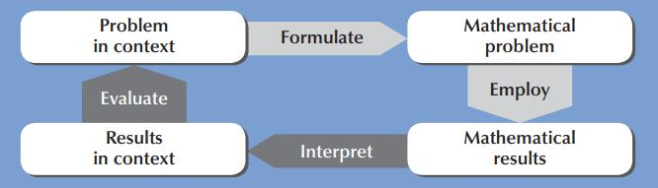

Possible Support Questions:

Explain your approach?
What would happen if you used the maximum amount of material?
How could you show these figures in a more efficient way?
Can you see a pattern in the numbers?
What do you notice about the variables?
What do you notice about the volume?
Could you generalise the information on the table?
What kind of mathematical expression would you get?
Is there any way of representing this mathematical equation?
Could you use a digital resource to get the solution?

