Mobile Phone Modelling Task

This task is adapted from the book:
Maasz, J., O’Meara, N., O’Donoghue, J., & Johnson, P. (2018). Mathematical modelling for teachers: A practical guide to applicable mathematics education. Dordrecht, NL: Springer.

Question: Which is the best bill pay mobile phone deal?
Resource https://switcher.ie/mobiles/

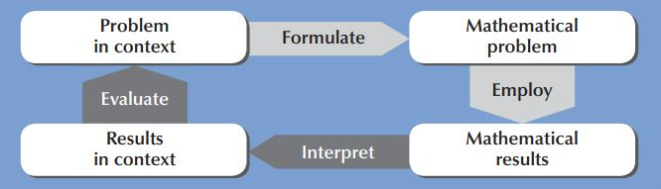

Questions for teachers to consider:
How would you give it a meaningful context for your TY students?
Could you collaborate with other teachers/departments(STEM or otherwise)/agencies to enrich the task?
How might students approach the task and how can they mathematise and generalise the situation?
What resources would help and what opportunities are there to use digital technology?
How will students be asked to present their work?

Questions to consider:
What do we mean by ‘best’ deal?
- Best deal for me?
- Best deal for a parent?

What variables are involved?
(Minutes, Texts, Data)

What assumptions do we need to make?
What approaches might a student take?
What support questions might we ask?
What extension questions can we ask?
What challenges for students may arise?
Sample Project:

Step 1:
Analyse your own plan usage (ask students to look at their previous bills)
Sort the information into important and unimportant.

Step 2:
Choose one important factor to focus on (e.g minutes)
Make assumptions - working to the nearest minute

Analyse:
Make a table, Graph the options https://www.geogebra.org/classic/nucd4wag

Discussion points:
Interpreting in context (what amount of minutes gives a particular plan better value)
Estimate based on bill analysis my average minutes
Which plan suits me best? (comparison using a framework)
Will I change my behaviour (move to flat rate because it is close to my average bill but I can talk without trying to save my minutes)? (connecting maths with reality)
Too much investment in the maths for just one case?(need for larger scale use)
Assumption for degree of accuracy - is there a problem with this?

Mathematical Content:
Piecewise function
Interpreting ‘word’ problems
Creating equations
Solving linear equations
Solving simultaneous equations

Next Steps:
Compare other users in your group with your model
Create a virtual user - investigate this case

Step 3: Extensions
Refine the model call minutes is not the only factor… what about texts & data?
Consider Data (moving to two variables)
Students might put in a slider for data to compare the effect of data on the function.
https://www.geogebra.org/classic/tvvmnj8u

Teachers could look at graphing functions of two variables and showing the graph to students for discussion/interpretation.

