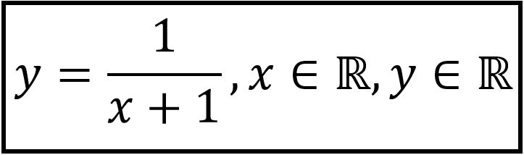

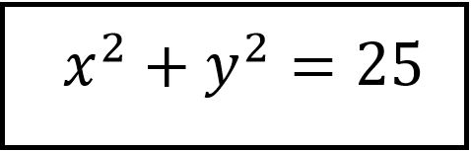

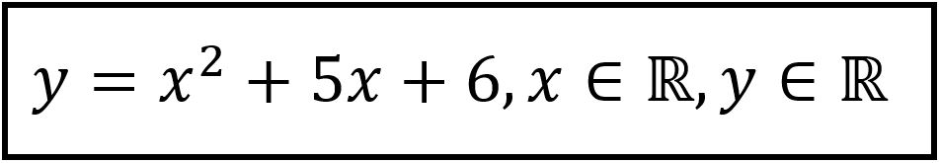

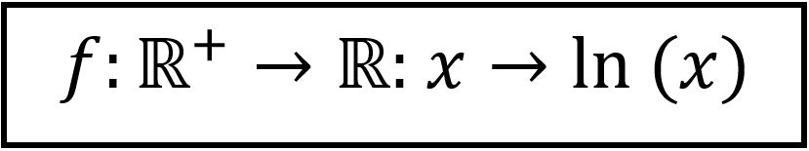

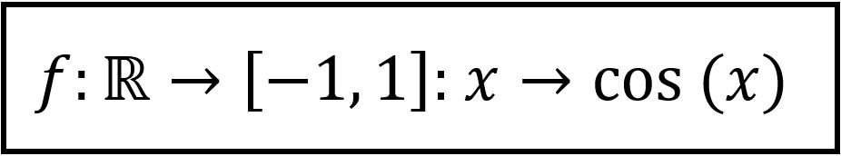

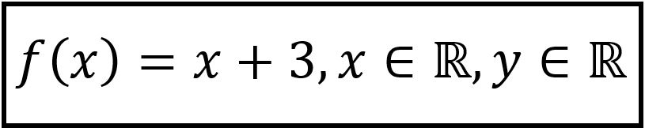

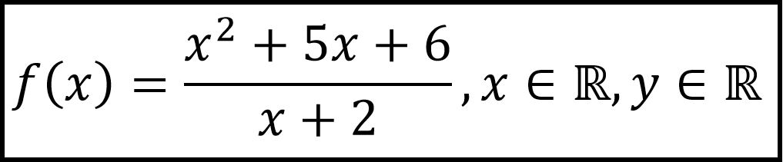

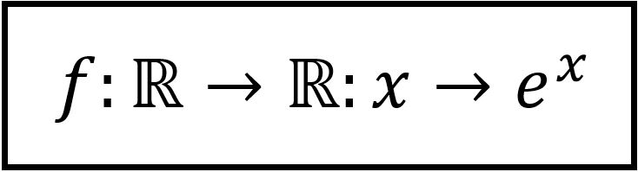

|  |  |
| --- | --- |
|  |  |
|  |  |
|  |  |
|  |  |

**Bijective Function**

**Bijective Function**

**Injective Function**

**Not a Function**

**Not a Function**

**Not a Function**

**Function - neither injective nor surjective**

**Surjective Function**