Activity B: Phoenix Shadow
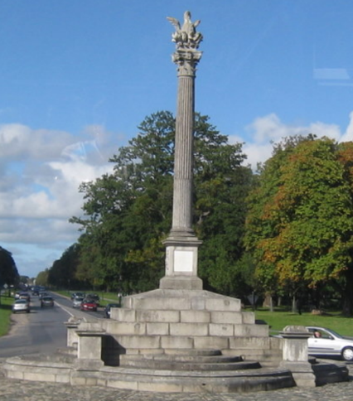
The function l(x) below gives the approximate length of the shadow created by the Phoenix Monument on Saturday 30th of March 2019 from 09.00 to 15.00
l(x) = 6.8(x - 3.1)² + 5
Where l(x) is the length of the shadow in metres, and x is the time in hours after 09.00

We want you to work through an activity around this for students.
What would you want them to do?
What would you want them to learn from this?
* Working with the complete square form is on the leaving cert. higher level course. You have the option of expressing this quadratic in standard form to adapt the activity for other levels.
l(x) = 6.8x² – 42.16x + 70.348

Your table will then have 5 minutes to present your work to another group.
Use your flip chart page(s) to gather and present your thoughts.
Consider highlighting key learning points.

----------------------------------------------------------------------------------------------------------------------------------------------
Activity B: Phoenix Shadow
- Graph: domain/range, discrete/continuous, graph setup (linking times to x-axis), sense making, recognising/understanding key points and symmetry (paper folding?), transformations (hour change, measure from centre of monument vs. edge of steps), limitations of the function to model real life
- Algebraic expression: solving equations, working with complete square form*, linking negative coefficient of x² term to u-shaped parabola, predicting key points
- Is there an opportunity to use IT to enhance the teaching and learning?
Consider students of different ability levels (including extension activities).
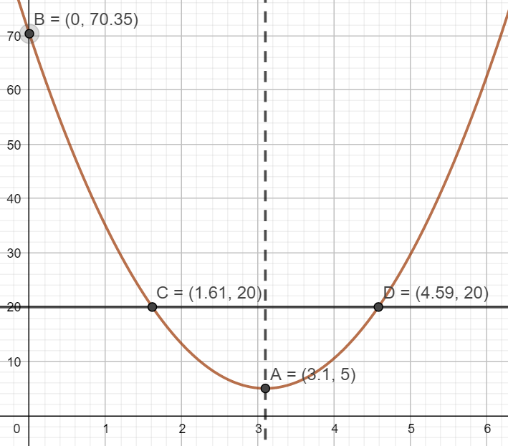

Activities (and Key Points) for Students
Setting up the graph: What is the domain? Range?
Which should go on the x-axis? y-axis?
Interpreting the graph and the algebraic expression:
Why would this context give a u-shaped parabola? Use the graph to tell a story…
Where is the y-intercept? What does it tell us about the shadow (relate to time)?
Where is the minimum? What does it tell us about the shadow (relate to time)?
Is the parabola symmetrical? If so, where is the axis of symmetry? Could you write its equation?
Where on the graph is the shadow shortest? What time is this? Could this have been predicted from the algebraic function?
When is the shadow 20m long?
Is it possible to have a 400m shadow? Explain your answer with reference to both your graph and your algebraic expression.
Why are there no (real) roots? Could there ever be? (In Summer: equal roots if the sun is straight overhead).

Transformations
1. This function fits a shadow measured from the edge of the steps at the base of the monument. The centre of the monument is 8.5m further back. Adapt the algebraic function and sketch the graph to match the length of the shadow from the centre of the monument.
2. The clocks went forward that Saturday night. How would the algebra and graph for March 31st 2019 look?
l(x-1) a horizontal shift.

Geogebra Activities
- Plot the parabola
- Identify the y-intercept. What does this tell us about the shadow?
(Use the Intersect tool )
- Find the minimum point of the parabola. What does this tell us about the shadow?
(Use the Extremum tool 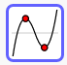)
- Find the dimensions that will give an area of 25m².
(Plot y = 25 and use the Intersect tool , to see where the line and parabola intersect)
- Does the parabola have an axis of symmetry?
(Use the Parallel line tool to plot a line through the maximum, parallel to the y-axis, then reflect the parabola about this line ).
Transformations
1. This function fits a shadow measured from the edge of the steps at the base of the monument. The centre of the monument is 8.5m further back. Plot the graph to match the length of the shadow measured from the centre of the monument. l(x) + 8.5 🡪 a vertical shift upwards.
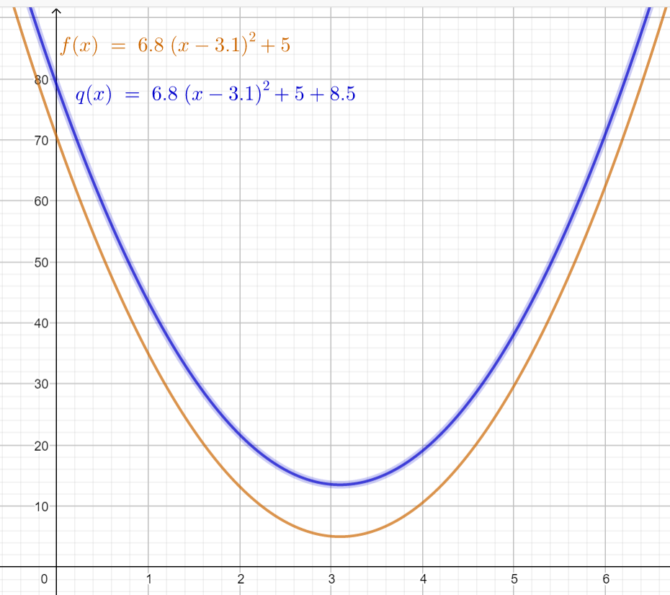
2. The clocks went forward that Saturday night. How would the algebra and graph for March 31st 2019 look?
l(x+1) 🡪 a horizontal shift to the left.
