Activity A: Sheep Pen
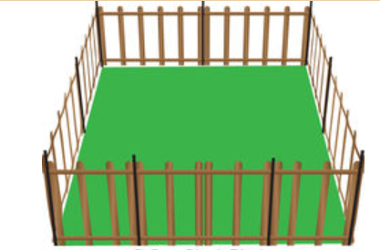
A farmer has 21m of fencing to enclose a 4-sided sheep pen (this includes a gate for the pen).
He wants to make the “biggest” pen possible.
We want you to work through an activity around this for students.
What would you want them to do?
What would you want them to learn from this?

Your table will then have 5 minutes to present your work to another group.
Use your flip chart page(s) to gather and present your thoughts.
Consider highlighting key learning points.

----------------------------------------------------------------------------------------------------------------------------------------------
Activity A: Sheep Pen

- Table: How much scaffolding is needed? Domain/range, Discrete vs. continuous.
- Graph: graph setup, sense making, recognising/understanding key points and symmetry (paper folding?), u/v shaped parabolas, transformations??
- Algebraic expression: formulating the expression, expanding brackets, factorising, solving equations, finding roots and understanding their meaning in context
- Is there an opportunity to use IT to enhance the teaching and learning?
- Consider students of different ability levels (including extension activities).

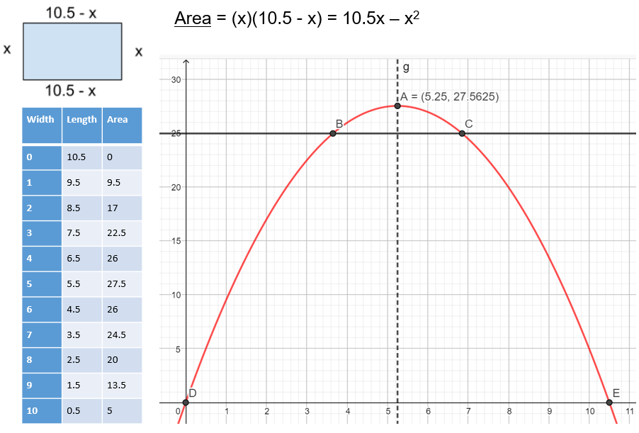

Activities (and Key Points) for Students
Understanding the Question: How do the 2 dimensions relate to each other and the given perimeter?
Forming the algebraic expression: Do we need 2 variables? What do any variables used represent?
Table: What input numbers make sense in the context of the question (integers, discrete/continuous)?
What kind of relationship (linear/quadratic) does width have to length? To area? How do you know? Rate of change!
Setting up the graph: What is the domain? Range?
Which should go on the x-axis? y-axis?
Interpreting the Graph:
Where are the roots? What do they tell us about the animal pen? How do they relate to the algebraic expression?
Where is the maximum? What does it tell us about the animal pen (dimensions, shape…) ?
Is the parabola symmetrical? If so, where is the axis of symmetry? Could you write its equation?
Find the dimensions that will give an area of 25m².
Is it possible to have a width of 12m? Explain your answer with reference to both your graph and your algebraic expression.

Geogebra Activities
- Plot the parabola
- Find the maximum point of the parabola. What does this tell us about the pen?
(Use the Extremum tool 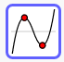)
- Find the roots. What do these tell us?
(Use the Roots tool 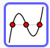)
- Find the dimensions that will give an area of 25m².
(Plot y = 25 and use the Intersect tool , to see where the line and parabola intersect)
- Does the parabola have an axis of symmetry?
(Use the Parallel line tool to plot a line through the maximum, parallel to the y-axis, then reflect the parabola about this line ).

