Lesson 1 - Review of Rates of Change

PART A
Look at the worksheet and answer questions relating to speed and rate of change. If you're having difficulty answering any of the questions - you might take a look at the accompanying video - entitled "Rates of Change Help Video".

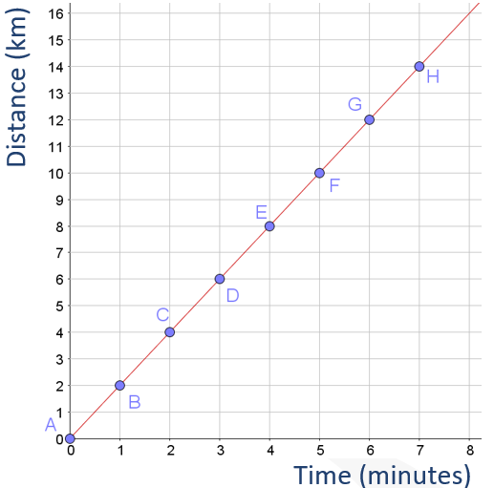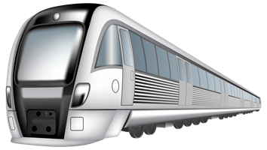
The graph shows time and distance information for a train, recorded by a passenger at a number of time intervals after leaving Heuston Station.
- What is the average speed of the train between minute 0 and minute 7?
- Calculate the slope of the graph.
- Do you notice any relationship between the average speed and the slope of the graph? What is the nature of this relationship? Why does this relationship exist?
- Is the train travelling at the same speed over the course of this seven-minute journey? How do you know?
- What is the speed of the train at exactly minute 4? Justify your answer.

PART B

Look at the learning intentions and success criteria listed below. Click on the link to the success criteria form and complete it. For any of the criteria for which you choose "not sure", write a brief description of why you don't think you've achieved this criteria in the relevant space in the form.

Learning Intentions
Students will be able to:
• calculate average speed
• recognise speed as a rate of change
• relate slope of a graph to rate of change
• recognise the characteristics of situations involving a constant rate of change
• understand that when dealing with situations with constant rate of change, rate of change at a point is the same as the average rate of change over an interval.

Success Criteria
- I can calculate average speed
- I can write a definition for a rate of change
- I can explain why speed is one example of a rate of change
- I can explain why the slope of a graph is the rate of change
- I can describe the relationship between a linear graph and rate of change
- I can provide a convincing argument as to why - for a linear graph - the rate of change at a point is the same as the average rate of change.

Link to success criteria form

