Lesson 4- Assignment 1

Learning to write coordinates in terms of x

Learning Intentions:
Students will be able to:
- choose appropriate notation to represent the coordinates of any point on a function
Success Criteria
- I can write the coordinates of a point on the graph of a function in the form (x, f(x))

In this assignment, we’re going to investigate how to write coordinates in generalised form in terms of x. This is going to be an important skill later in this lesson.

Section A
Let’s consider the function f(x)=x² which is shown in the graph below.
- For each of the inputs in the table below – determine the corresponding output for the function and write the inputs and outputs as coordinates in the third column.
f (x) = x²
Input: x= | Output: y= | Coordinate of Point on Function
0 |  | ( , )
1 |  | ( , )
2 |  | ( , )
3 |  | ( , )
26 |  | ( , )
x |  | ( , )

- Locate as many points from your table on the graph below.
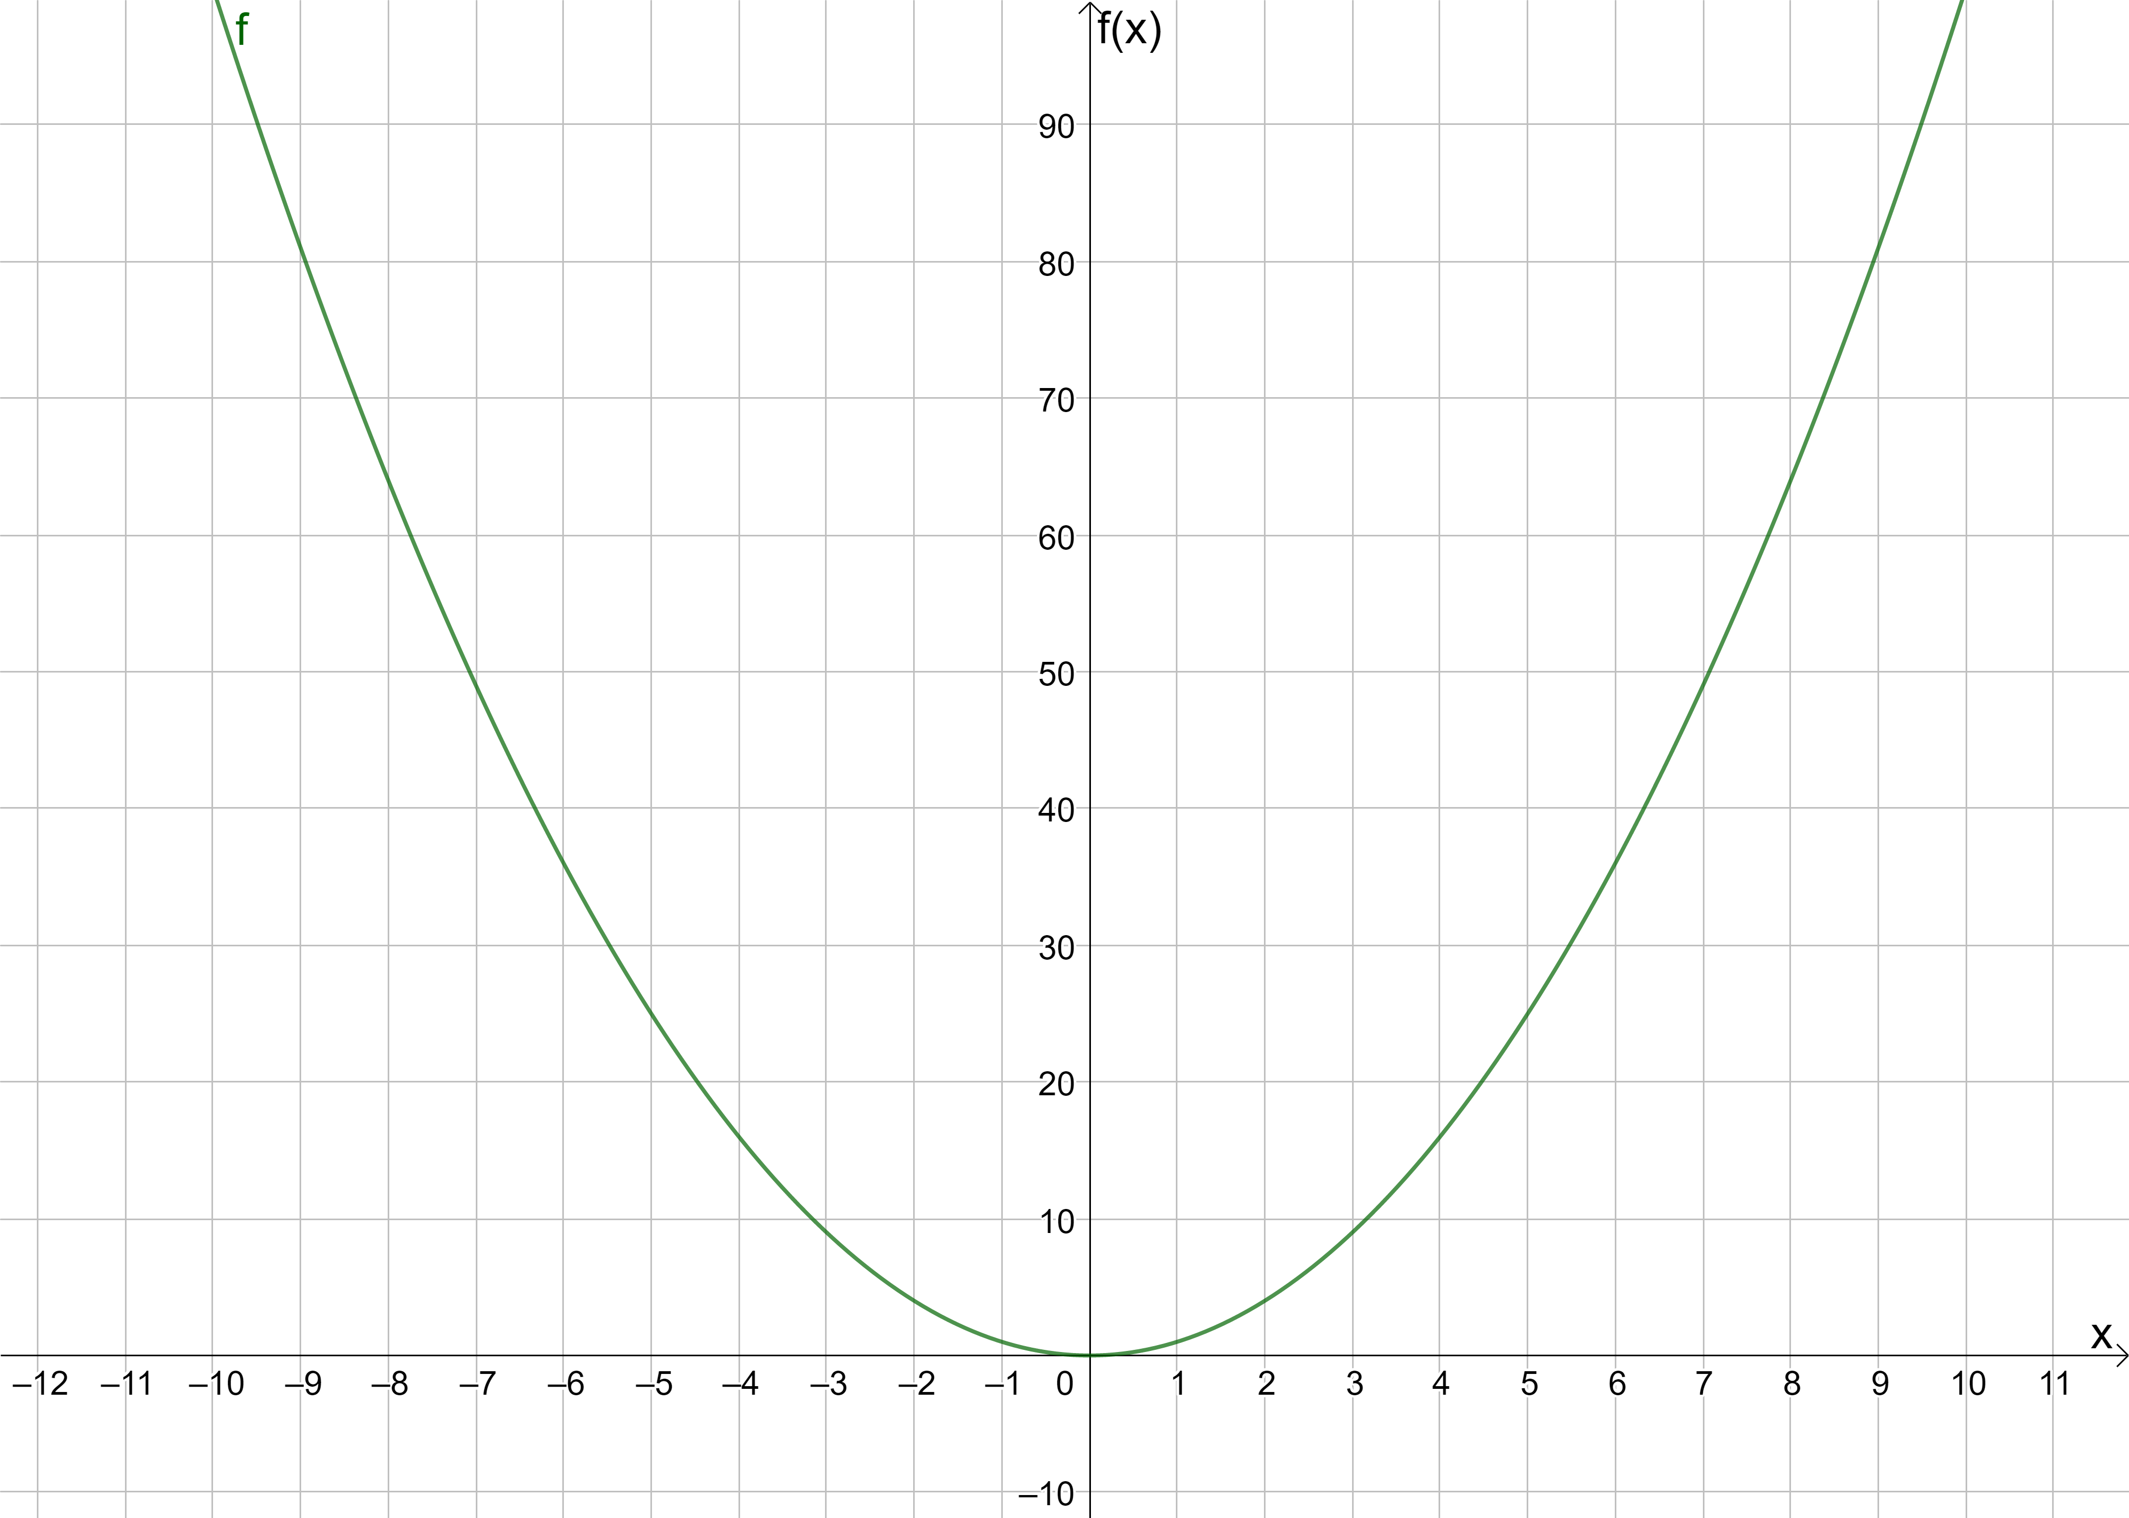

If you had difficulty completing Question 1 and 2 – take a look at this short help video. Only watch up to the 2:20 mark in the video.
Section B
- We now know that any point on my function has generalised coordinates, in terms of x, of (x, x²). Let’s look at writing down generalised coordinates for points to the right of our point (x, x²)
Input: x= | Output: y= | Coordinate of Point on Function | Note
x + 1 |  | ( , ) | 1 unit to the right of x
x + 2 |  | ( , ) | 2 units to the right of x
x + h |  | ( , ) | h units to the right of x

- Mark in as many of these points from your table on the graph below (you may assume that each mark on the horizontal axis represents one unit).
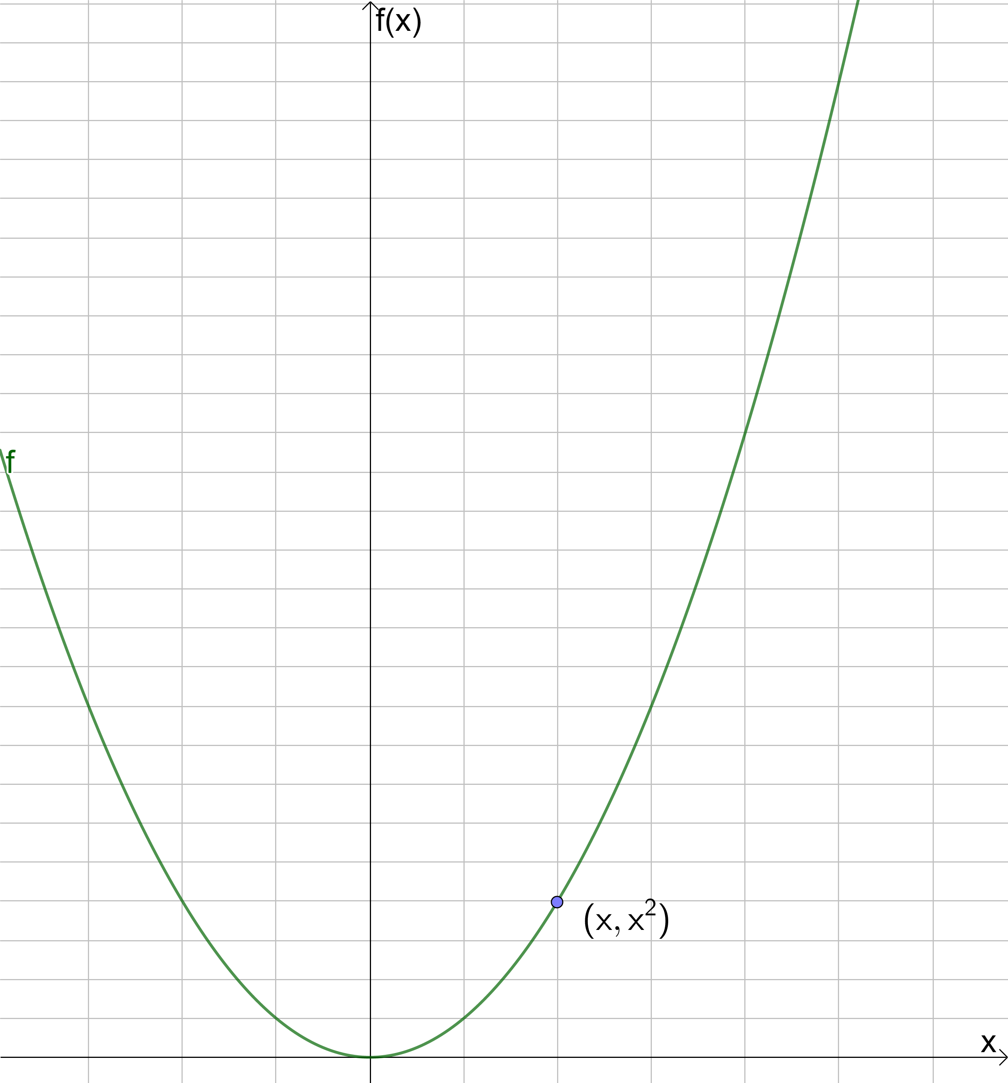
If you had difficulty completing Question 3 and Question 4 – take a look at this short help video. If you watched the first part of the video already, only watch from 2:20 onwards.
- Write down coordinates for each point given for the following functions
g (x) = 2x²
 | Input: x= | Output: y= | Coordinate of Point on Function
(a) | 1 |  | ( , )
(b) | 2 |  | ( , )
(c) | 10 |  | ( , )
(d) | x |  | ( , )
(e) | x + h |  | ( , )

a (x) = x² +3x
 | Input: x= | Output: y= | Coordinate of Point on Function
(a) | 1 |  | ( , )
(b) | 20 |  | ( , )
(c) | 100 |  | ( , )
(d) | x |  | ( , )
(e) | x + h |  | ( , )

q (x) = x² +4x-3
 | Input: x= | Output: y= | Coordinate of Point on Function
(a) | 1 |  | ( , )
(b) | 5 |  | ( , )
(c) | 10 |  | ( , )
(d) | x |  | ( , )
(e) | x + h |  | ( , )

- This GeoGebra file has two points marked on it A and B. Point A has an x-coordinate of x and Point B has an x-coordinate of x+h. Drag the slider named “Question” until you find each of the above functions and click on the different tick boxes to check your answers to parts (d) and (e) from the tables in Q5.
- If you want additional practice in writing down generalised coordinates – try out the other questions on the GeoGebra file by dragging the slider named “Question”.

