Activity Sheet 1 Code Breaker
A code must consist of 3 letters.
List all the possible codes that can be made from the letters you have been given, in the box below.
e.g. ABC

How many codes have you?

How many choices do you have for the 1st letter?

If A is picked, how many choices do you now have for the 2nd letter?

If B is then picked, how many choices do you now have for the 3rd letter?

Can you come up with an easier way of arriving at your answer for the above question?

Activity Sheet 1 Code Breaker with Answers
A code must consist of 3 letters.
List all the possible codes that can be made from the letters you have been given, in the box below.
e.g. ABC
ABC, ACB, BAC, BCA, CAB, CBA.

How many codes have you?
6

How many choices do you have for the 1st letter?
3

If A is picked, how many choices do you now have for the 2nd letter?

2

If B is then picked, how many choices do you now have for the 3rd letter?

1

Can you come up with an easier way of arriving at your answer for the above question?

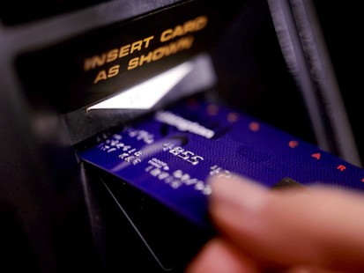
Activity Sheet 2. ATM

You must choose a new 4 digit ATM pin number from the numbers 5, 0, 3, 8.
List all the possible pin numbers in the space below.

How many pin numbers in total are possible?

How many of these pin numbers begin with 3?

How many of these pin numbers are greater than 4000?

Can you come up with an easier way of arriving at your answer for the above question?

How many of these pin numbers are less than 1000?

How many of the pin numbers are odd numbers?

What are the chances that your pin number is odd?

Activity Sheet 2 ATM with answers

You must choose a new 4 digit ATM pin number from the numbers 5, 0, 3, 8.
List all the possible pin numbers in the space below.
0358 3058 5038 8035
0385 3085 5083 8053
0538 3508 5308 8305
0583 3580 5380 8350
0835 3805 5803 8503
0853 3850 5830 8530

How many pin numbers in total are possible?

24

How many of these pin numbers begin with 3?
6

How many of these pin numbers are greater than 4000?
12

Can you come up with an easier way of arriving at your answer for the above question?
2x3x2x1=12

How many of these pin numbers are less than 1000?
6

How many of the pin numbers are odd numbers?

12

What are the chances that your pin number is odd?

Activity Sheet 3: Code Breaker 2
A code must consist of 3 letters followed by 2 numbers.
List all the possible codes that can be made from the letters and numbers you have been given, in the box below.
e.g. ABC12

How many codes have you?

How many choices do you have for the 1st letter?

If A is picked, how many choices do you now have for the 2nd letter?

If B is then picked, how many choices do you now have for the 3rd letter?

How many choices do you have for the 1st digit?

If 1 is picked, how many choices do you now have for the 2nd digit?

Can you come up with an easier way of arriving at your answer for the above question?

If the above letters & numbers could be arranged in any order, how many codes are now possible?

Activity Sheet 3: Code Breaker 2 with answers
A code must consist of 3 letters followed by 2 numbers.
List all the possible codes that can be made from the letters and numbers you have been given, in the box below.
e.g. ABC12

ABC12 BAC12 CAB12
ABC21 BAC21 CAB21
ACB12 BCA12 CBA12
ACB21 BAC21 CBA21

How many codes have you? 12

How many choices do you have for the 1st letter?
3

If A is picked, how many choices do you now have for the 2nd letter?

2

If B is then picked, how many choices do you now have for the 3rd letter?

1

How many choices do you have for the 1st digit?
2

If 1 is picked, how many choices do you now have for the 2nd digit?

1

Can you come up with an easier way of arriving at your answer for the above question?

3X2X1X2X1=12

If the above letters & numbers could be arranged in any order, how many codes are now possible?

5X4X3X2X1=120

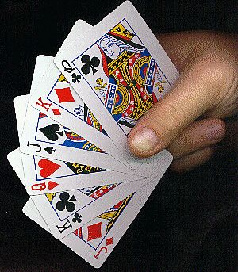
Activity Sheet 4: What are the chances?.......

A deck of cards is shuffled, and turned upside down in front of you.
Answer the following questions, giving a reason for your answers:
Question 1: Will I definitely choose a red card?

2. Which of the following statements BEST describes my chances of choosing a RED card:
I will not choose a red card.
I might choose a red card.
I will probably choose a red card.
I have equal chances of choosing a Red or a Black card.
Reason:

3. What are the chances of choosing a Black card?

4. What are the chances of choosing a King?

5. What are the chances of choosing a Red King?

6. What are the chances of choosing a picture card?

Activity Sheet 4: What are the chances?....with answers.

A deck of cards is shuffled, and turned upside down in front of you.
Answer the following questions, giving a reason for your answers:
Question 1: Will I definitely choose a red card?
NO

2. Which of the following statements BEST describes my chances of choosing a RED card:
I will not choose a red card.
I might choose a red card.
I will probably choose a red card.
I have equal chances of choosing a Red or a Black card.
Reason:
There are the same number of red cards in the deck as black cards.

3. What are the chances of choosing a Black card?

4. What are the chances of choosing a King?

5. What are the chances of choosing a Red King?

6. What are the chances of choosing a picture card?

